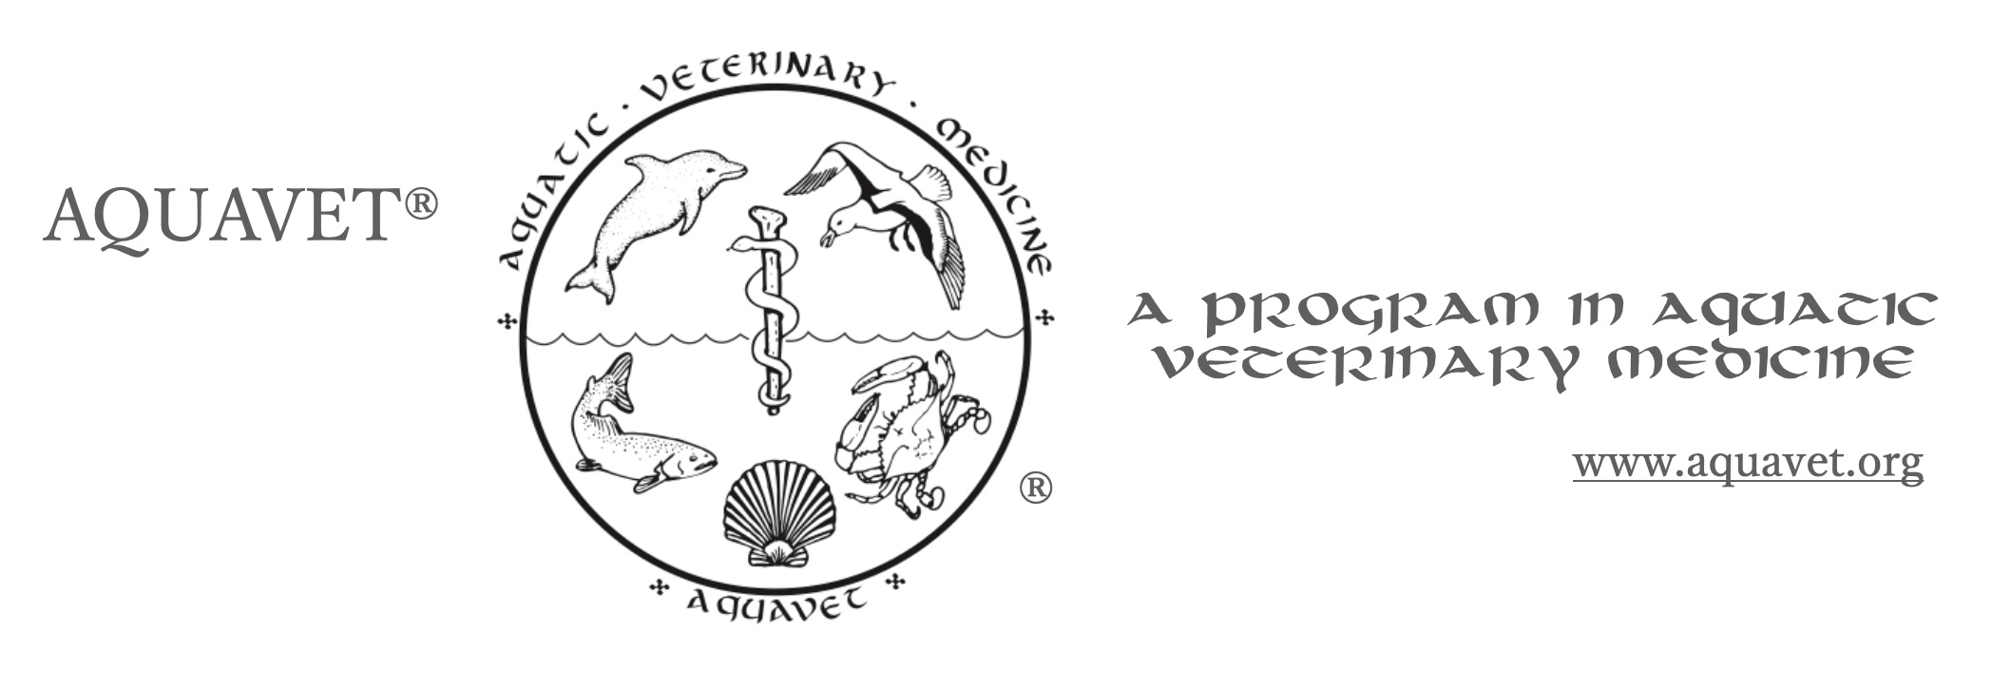

Locations:

Marine and Natural Sciences Building = MNS

Lecture rooms: MNS 200, MNS 210, MNS 213

Labs: MNS 103

**Monday, 26. May 2025 – Memorial Day**

11:00-12:00 Registration – Check-In

Bayside

Apartments

12:30 Orientation

MNS 200 Dr. Donald W. Stremme – Cornell University

AQUAVET® Director

13:30 RWU Required Safety Lecture

MNS 200 Caitlin Conley

14:30 History of AQUAVET®

MNS 200 Dr. Laurie Landeau – Marinetics, Inc.

AQUAVET® Associate Director

16:00 Normal Anatomy of Bivalves

MNS 213 Dr. Jennifer Dill- Regeneron

17:30 dinner

18:30 Normal Anatomy of Bivalves

MNS 213 Dr. Dill

19:30 **Welcome to AQUAVET Party**

Dorm Courtyard Area (weather permitting)

**Tuesday, 27. May 2025**

8:00 Diseases of Bivalves

MNS 213 Dr. Alisa Newton – OCEARCH – ZooQuatic Laboratory

13:00 Anatomy and Diseases of Cephalopods

MNS 213 Dr. Jennifer Dill- Regeneron

18:30 Anatomy and Diseases of Echinoderms

MNS 213 Dr. Newton

**Wednesday, 28. May 2025**

8:00 Parasites in Aquatic Animals

MNS 213 Dr. Sarah Poynton - John Hopkins Medical University, School of

Medicine

13:00 Anatomy and Diseases of Echinoderms (Continued)

MNS 213 Dr. Newton

15:00 Anatomy and Diseases of Crustaceans

MNS 213 Dr. Newton

18:30 Anatomy and Diseases of Crustaceans (continued)

MNS 213 Dr. Newton

**Thursday, 29. May 2025**

8:00 **Invertebrate Pathology – WET LAB**

MNS 103 **(need dissection kit, lab coats)**

Drs. Dill and Newton

13:00 **Invertebrate Pathology – WET LAB (continued)**

MNS 103 **(need dissection kit, lab coats)**

Drs. Dill and Newton

18:30 Aquaculture Vaccine Reactions Histologically Speaking

MNS 213 Dr. Rod Getchell – Cornell University

AQUAVET® Associate Director

**Friday, 30. May 2025**

8:00 Amphibian Pathology I

MNS 213 Dr. Rob Ossiboff - U FL Aquatic, Amphibian, and Reptile Pathology

Program, College of Veterinary Medicine

10:00 Amphibian Pathology II

MNS 213 Dr. Ossiboff

13:00 Diagnosis of Pathogens Affecting Shellfish: Methods and Regulatory

MNS 213 Requirements

Dr. Marta Gomez-Chiarri – University of Rhode Island

15:00 Using Animals in Research and the Role of IACUC

**MNS 200** Dr. Lisa Abbo – Marine Biological Laboratory

18:30 Toxicologic Pathology of Fishes

MNS 213 Dr. Jeff Wolf - Experimental Pathology Laboratories, Inc.

**Saturday, 31. May 2025**

8:00 Toxicologic Pathology of Fishes (continued)

MNS 213 Dr. Wolf

13:00 Toxicologic Pathology of Fishes (continued)

MNS 213 Dr. Wolf

18:30 Toxicologic Pathology of Fishes (continued)

MNS 213 Dr. Wolf

**Sunday, 1. June 2025**

8:00 Toxicologic Pathology of Fishes (continued)

MNS 213 Dr. Wolf

13:00 Toxicologic Pathology of Fishes (continued)

MNS 213 Dr. Wolf

19:00 **AQUAVET® Joint Class Picnic**

courtyard

**Monday, 2. June 2025** – OFF

Morning OPTIONAL Whale Watch

Barnstable, MA

**Tuesday, 3. June 2025**

8:00 Neoplasia of Fish / Non-Infectious Diseases of Aquaculture Species

MNS 213 Dr. Sal Frasca – ZooQuatic, LLC

Dr. Emily Reinhardt - University of Connecticut

13:00 Fish Hematology

MNS 213 Jill Arnold – ZooQuatic, LLC

18:30 Fish as Lab Animals

MNS 213 Dr. Jan Lovy – USGS Western Fisheries Research Center

19:30 Electron Microscopy in Diagnostic Fish Virology

MNS 213 Dr. Lovy

**Wednesday, 4. June 2025**

8:00 Diseases of Coldwater Aquaculture Species – Bacterial and Viral

MNS 213 Diseases

Dr. Lovy

Dr. Thomas Loch – MSU-AAHL, Colleges of Agriculture & Natural

Resources and Veterinary Medicine

13:00 Diseases of Coldwater Aquaculture Species – Fungal, Protozoan

MNS 213 and Myxozoan Diseases

Drs. Lovy, Loch, Frasca, Reinhardt

18:30 Elasmobranch Histology

MNS 213 Drs. Frasca and Newton

**Thursday, 5. June 2025**

8:00 **RWU Shellfish Hatchery visit**

Shawna Chamberlin – Roger Williams University

9:00 Introduction to Diseases of Aquaculture Species – Warmwater -

MNS 213 Catfish

Dr. Sherman Jack – Mississippi State University, CVM

13:00 Pathology of Catfish Diseases

MNS 213 Dr. Jack

18:30 Diagnostic Case Studies and Practicum - Aquacultured Species

MNS 213 Drs. Jack and Getchell

**Friday, 6. June 2025**

8:00 **Fish Diagnostics and Techniques WET LAB**

MNS 103 **(need dissection kit, lab coats)**

Dr. Rod Getchell

10:00 Slide Viewing/ Conundrums

MNS 213 Dr. Rod Getchell

13:00 Corals - Gross Pathology

MNS 213 Dr. Michelle Dennis - University of Tennessee - CVM

18:30 Corals - Histopathology

MNS 213 Dr. Dennis

**Saturday, 7. June 2025**

8:00 Overview of the Principal Infectious Diseases Found in Farmed Penaeid

MNS 213 Shrimp

Dr. Bob Bullis – Florida Keys Community College

Dr. Arun Dhar – University of AZ, Aquatic Pathology Laboratory

13:00 Overview of the Principal Infectious Diseases Found in Farmed Penaeid

MNS 213 Shrimp

Drs. Dhar and Bullis

18:30 **AQUAVET®II Clambake**

**Sunday, 8. June 2025**

By 10:00 check out – back to reality