
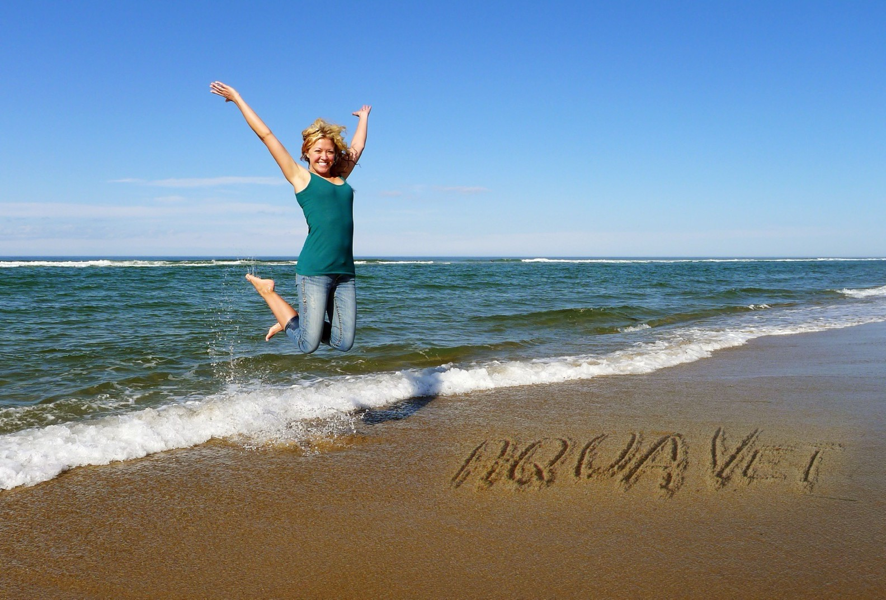
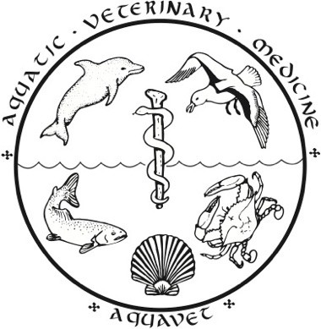

Photo: Melchior de Bruin

AQUAVET® Information for 2026


AQUAVET®
Background Information





- Need for trained veterinary professionals
  - contribute to the health/welfare of aquatic animals and their environment
  - Began in the spring of 1977
- Historically sponsored by
  - University of Pennsylvania
  - Cornell University


AQUAVET®
Course Information








- Three opportunities
  - AQUAVET® I
    - Introduction to Aquatic Veterinary Medicine
    - 4 week course
  - AQUAVET® II
    - Comparative Pathology of Aquatic Animals
    - 2 week course
  - AQUAVET® Summer fellowship
    - Usual Location: Fish Diagnostics Lab at Cornell
    - Usual Topic: a selected fish viral disease
    - Duration: 8 weeks


Logistics – AQUAVET®
I & II






- Roger Williams University - Bristol, RI
- Classrooms and labs
- Library
- Tuition covers course work, housing and most meals
- Housing – suites with kitchen and 2 bedrooms
  - 4 students per suite
  - roommate
  - no pets
- Meals – cafeteria meal plan
  - Breakfast, lunch, dinner
  - 5-10 stations

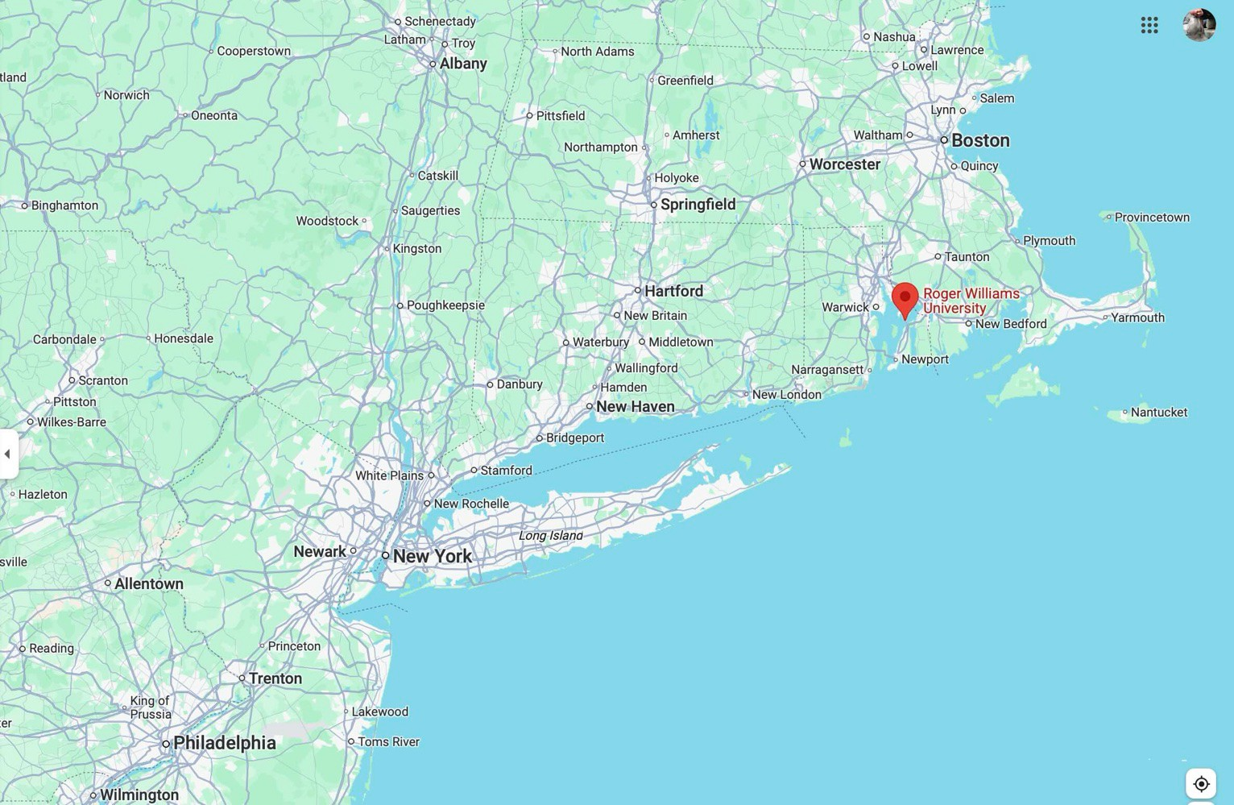
20 min to Newport
20 min to Providence

Location Bristol, R.I.

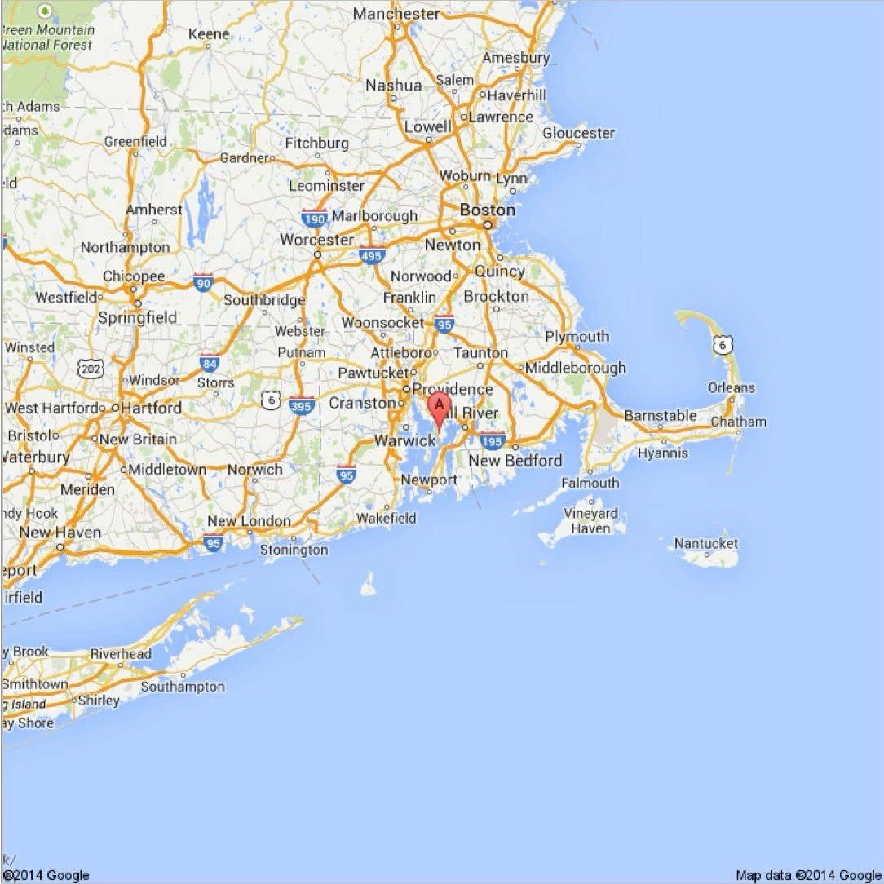

Bristol, R.I.

Just 1-1.5 hours to:
- Boston
- Mystic
- Barnstable





Bliihewold Marmion,0, Ga,demi & A,bo,etum



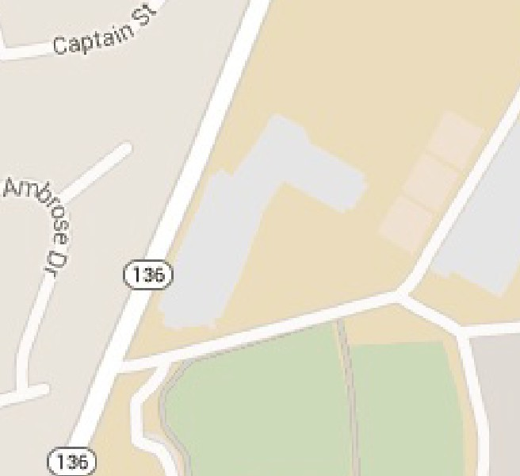
f..:\ ELS Language




\!!I Centers - Bristol

"!I


Roger Williams Unil'lllSi�y

Unive,si�y Libra,y@

@ Erlgineering Sd-mol
- James L MBher Ceriler

"'iJ
i
!/;-


Ferry CMf

RWU
Campus
B,ank of America ATM@


Q,:
i;,,,<\
�
i,


Q9


Bri�tol Po/111

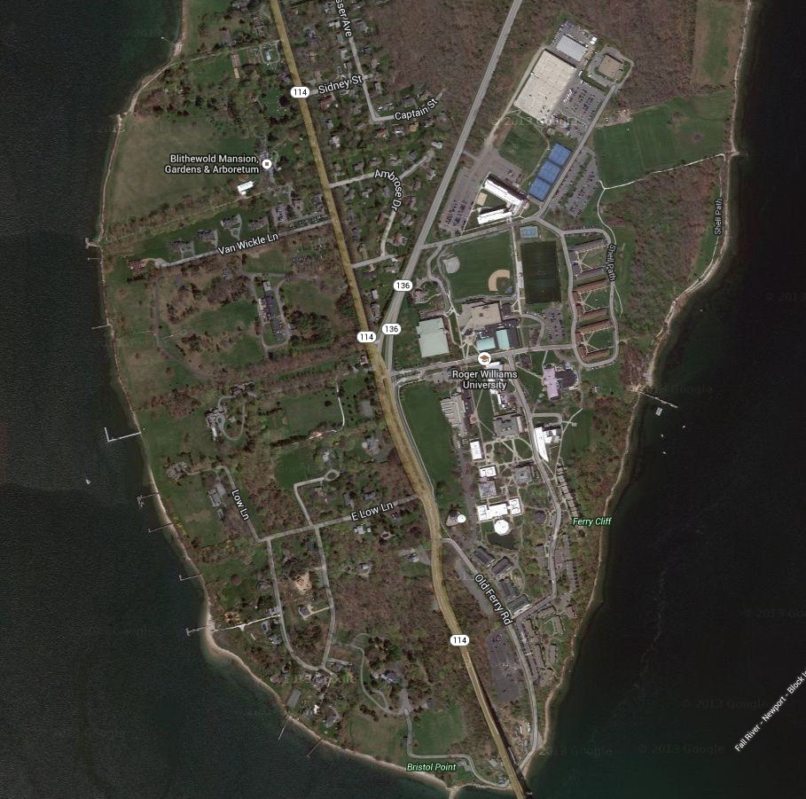

RWU
Campus

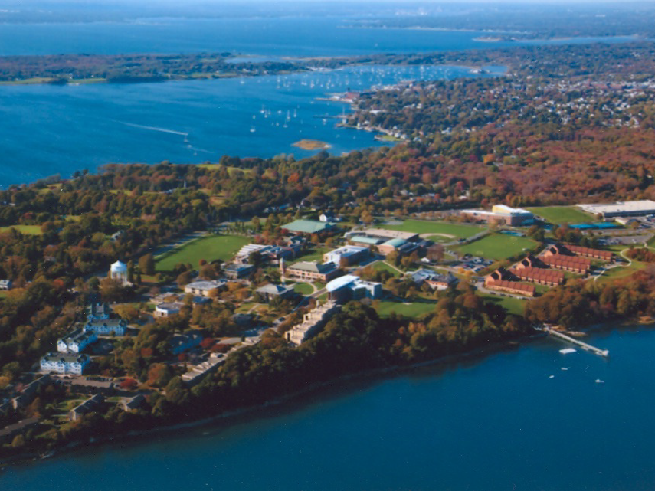

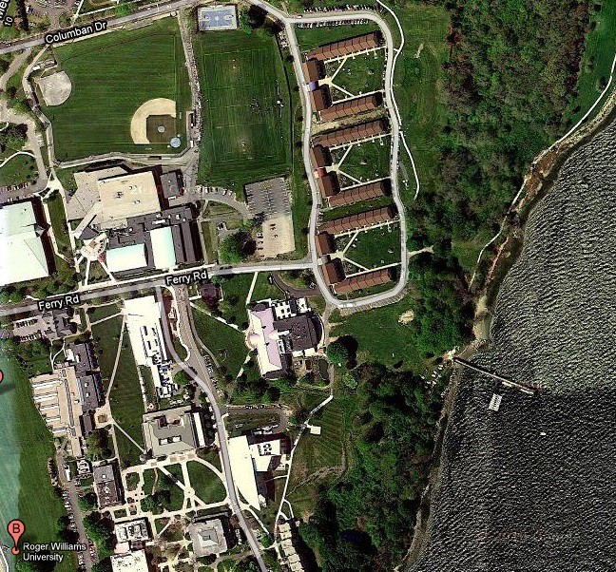


COURSES at RWU







AQUAVET® I:
An Introduction to Aquatic Veterinary Medicine
4 weeks: total immersion course 25 May to 21 June 2026
22-24 Students
Approx. 46 invited faculty
AQUAVET® II:
Comparative Pathology of Aquatic Animals
2 weeks: total immersion course 25 May to 7 June 2026
12-18 students
Approx. 15 invited faculty

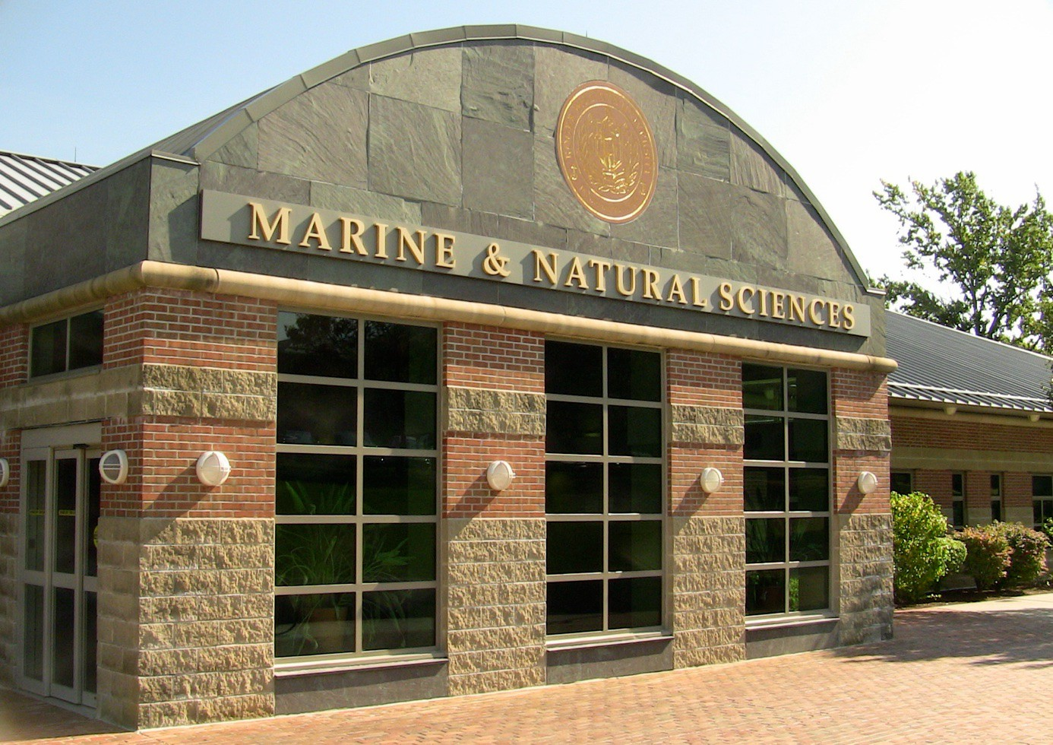
AQUAVET® Home

Marine and Natural Sciences Building

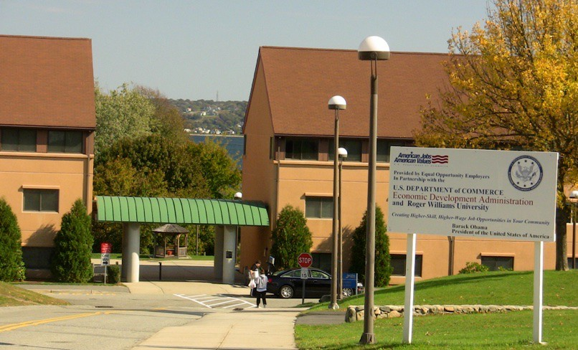
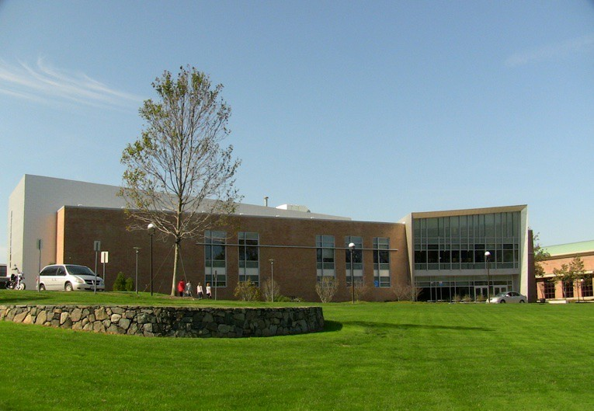

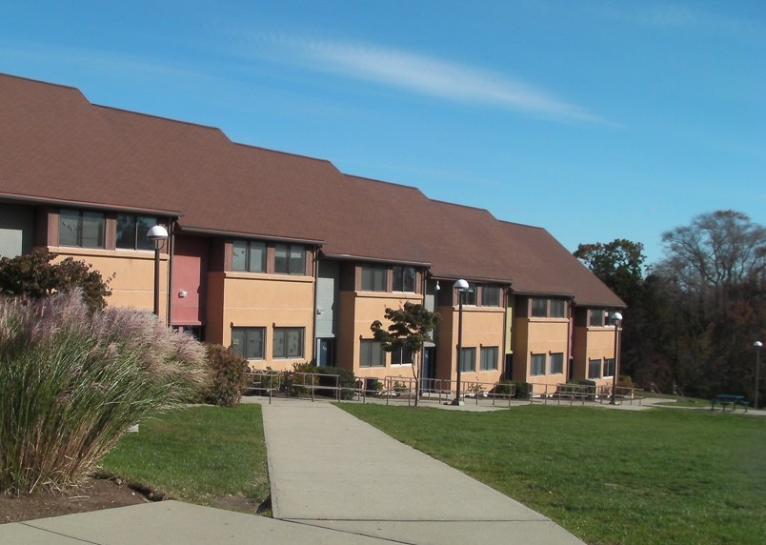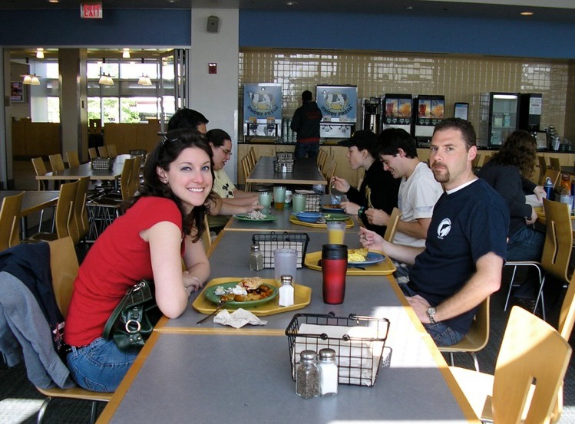

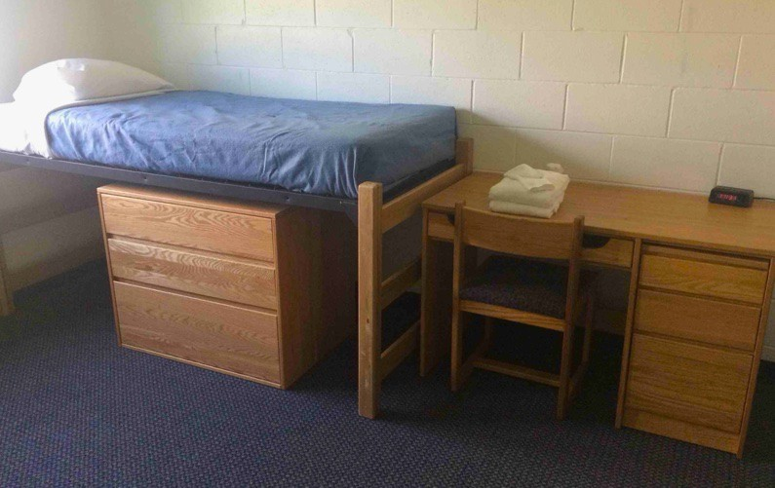

Typical Dorm Room
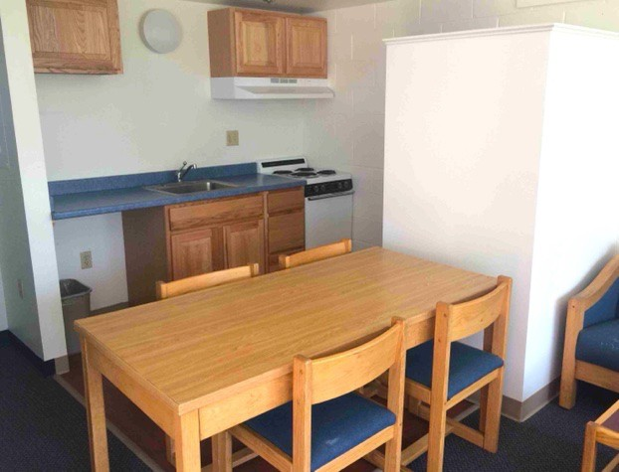
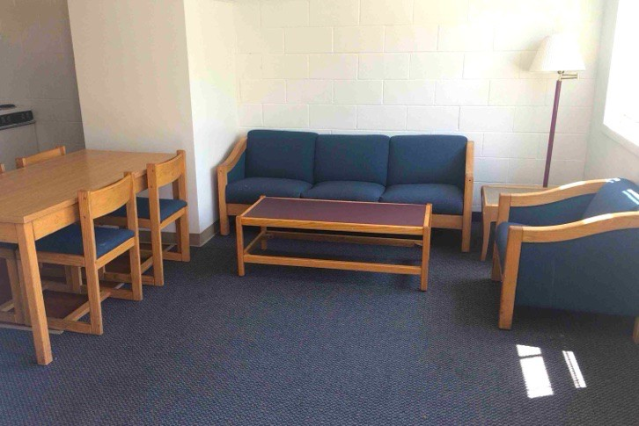
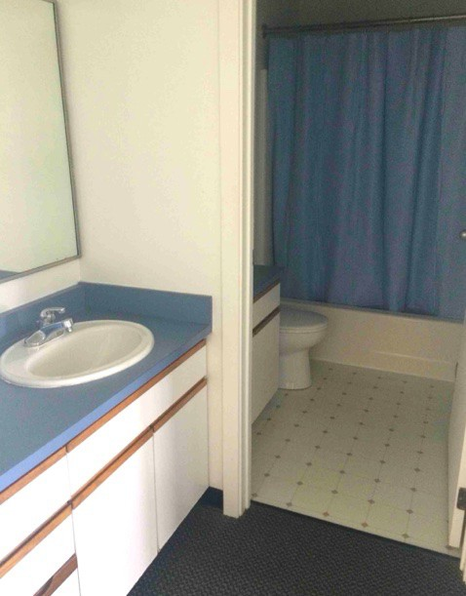

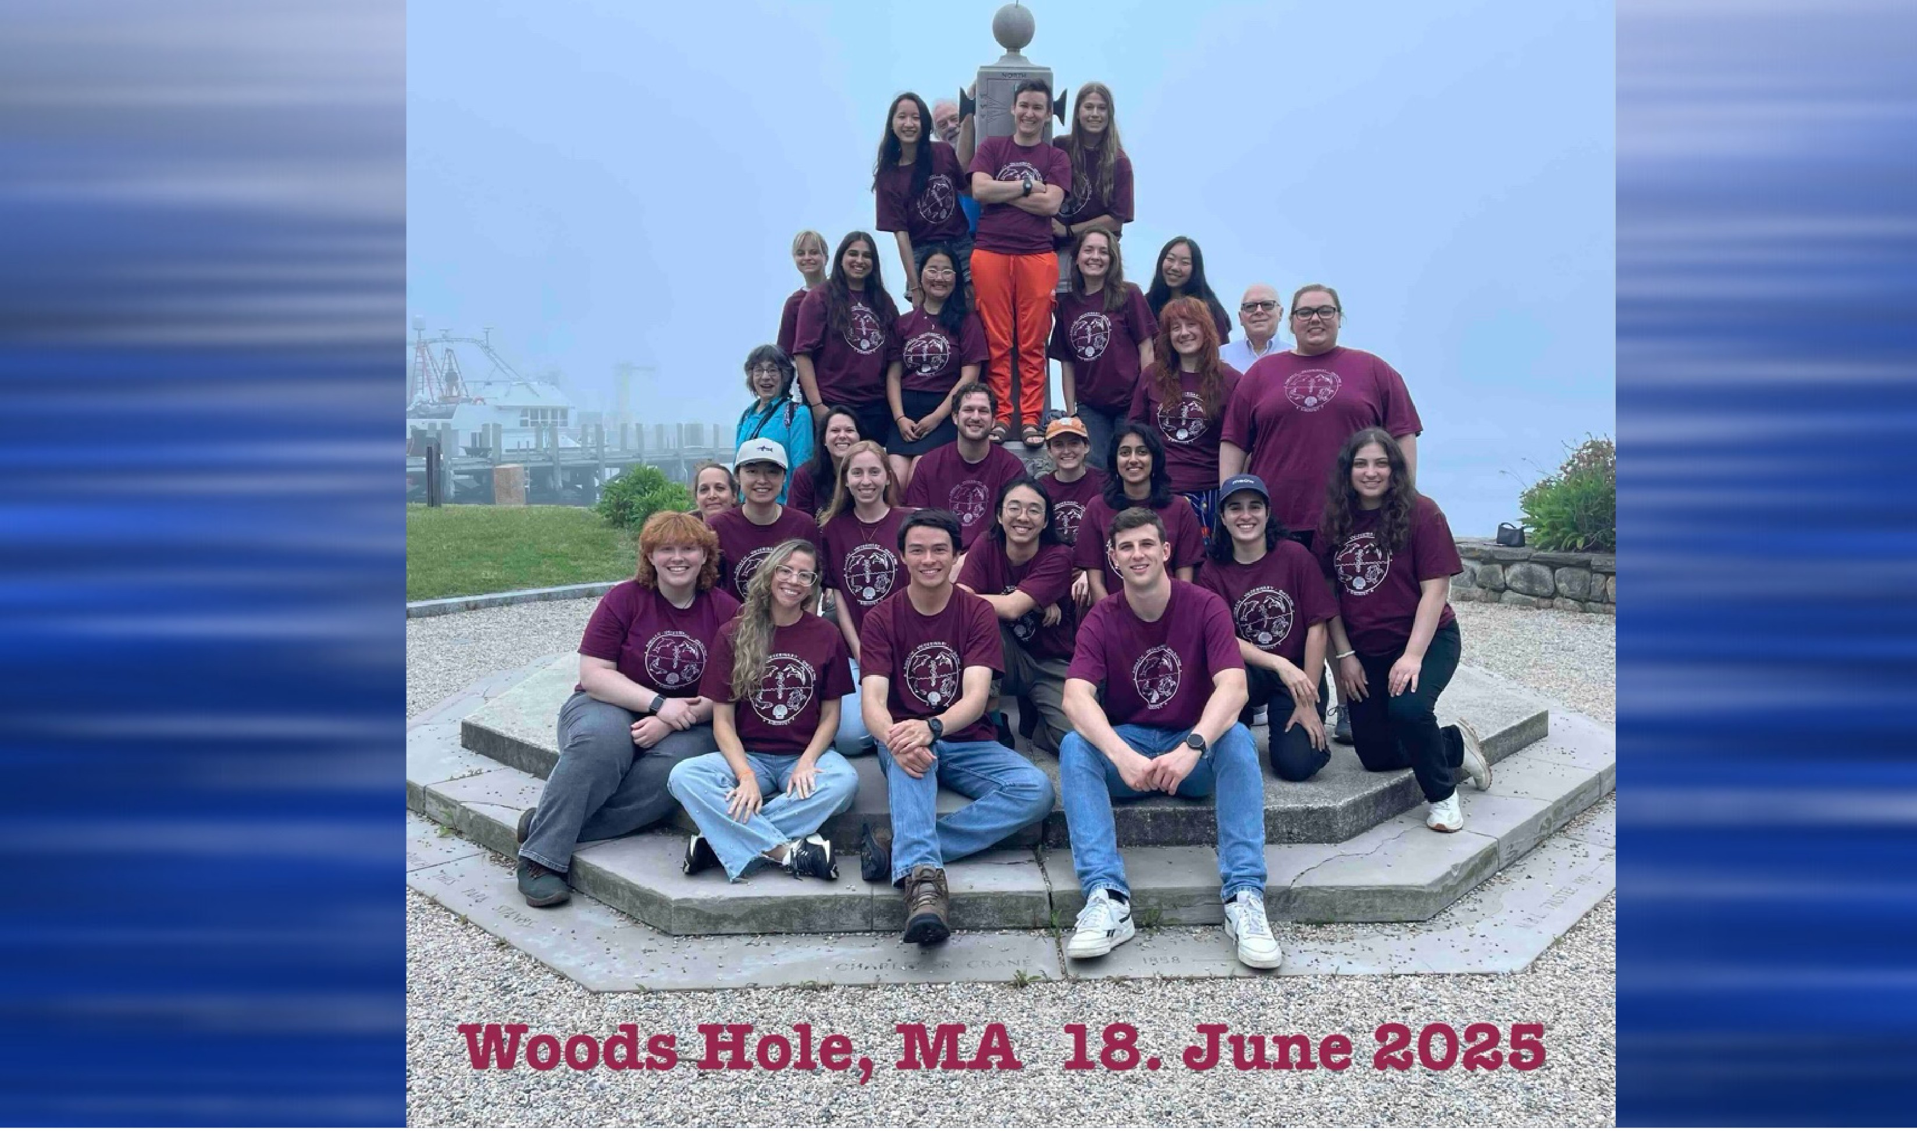
2025 AQUAVET®I Class


AQUAVET® I
Introduction to Aquatic Veterinary Medicine

- Four weeks – begins May 25 and ends June 21
- Classes routinely 6 days a week
(and most evenings)


- Water Quality
- Invertebrates to marine mammals


- Lectures and laboratory sessions
- Field trips
- Student seminars

AQUAVET® I
Introduction to Aquatic Veterinary Medicine

Invertebrates to marine mammals



- Aquatic invertebrates
- Fish


- Amphibians and Reptiles
- Sea Turtles


- Aquatic Birds
- Marine Mammals


AQUAVET® I






- Field trips
  - Intertidal Invertebrate Collecting
  - Mystic Aquarium
  - New England Aquarium
  - Atlantis Marine World
  - Riverhead Foundation for Marine Research and Preservation
  - WHOI (Woods Hole Oceanographic Institute)

AQUAVET® I






- Tuition for Students - $3,500
  - Less $200 from anonymous donor = $3,300
  - Includes
    - Tuition
    - Room and board - 4 weeks
- Required to attend class
  - Foundation covering 2/3 of cost



- Credit Available – depending on school
  - Evaluation based on
    - Participation in all aspects of the course
    - Especially student seminars


AQUAVET®
I Cost Comparisons


















Tuition - $3,500 - $200 = $3,300
    - Compare:

AQUAVET®I – 4 weeks
      - about $825/week
      - Includes
      - Tuition
      - Room and board

MarVet – 1-2 weeks
      - About $1,500/week
      - Includes only some meals

SeaVet – about $575 for 10 days
      - About $400/week
      - Includes only some meals
      - Does NOT include housing

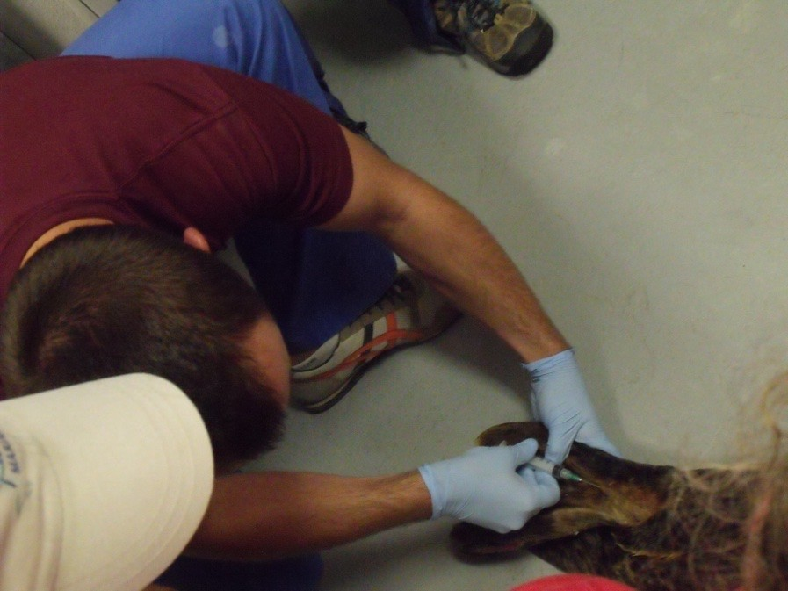
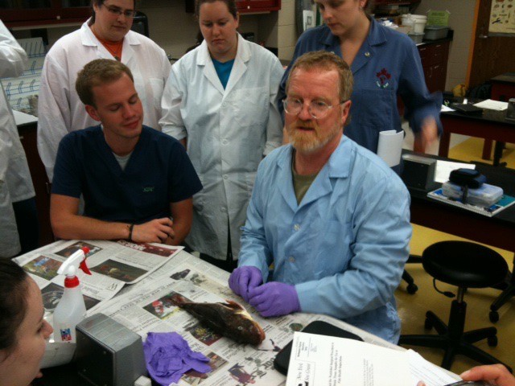
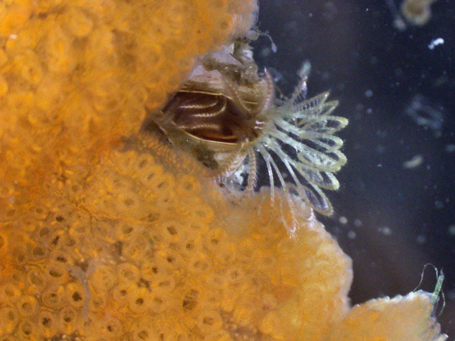
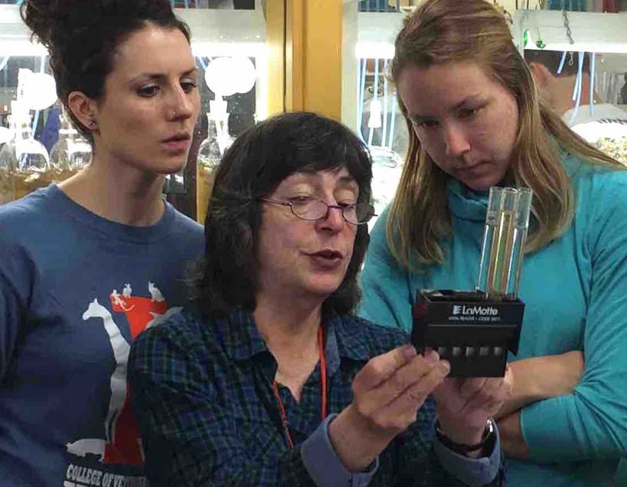

Scenes from AQUAVET® I

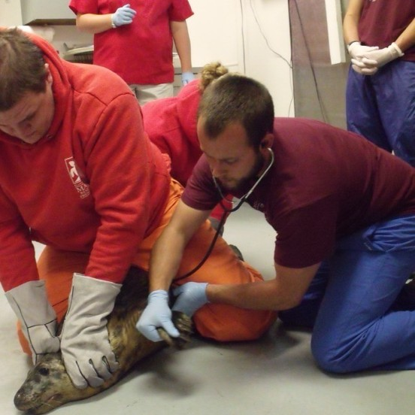
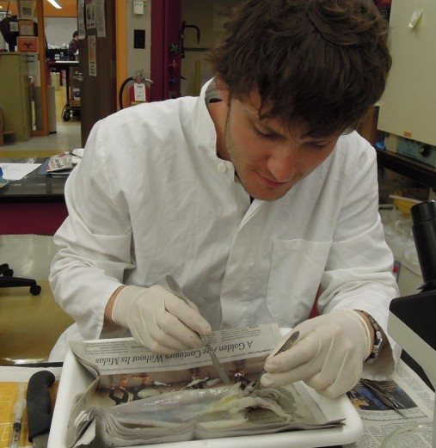
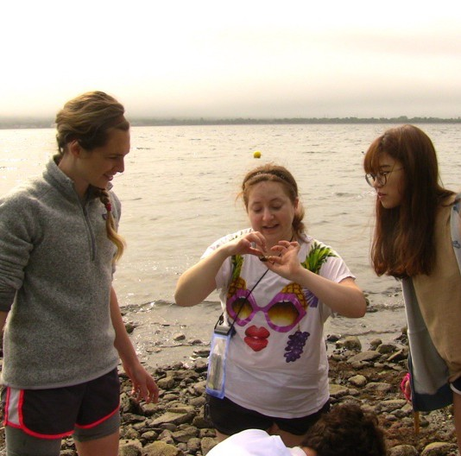
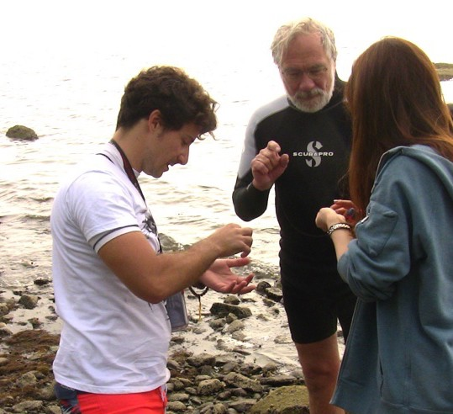
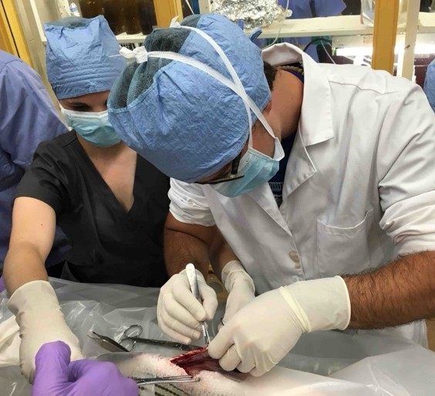
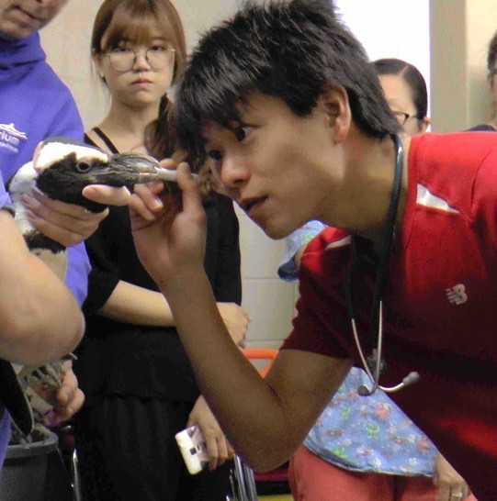

Scenes from AQUAVET® I

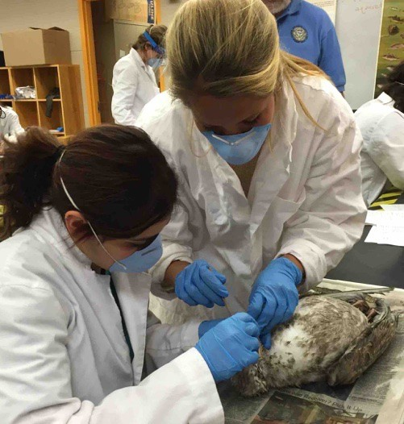
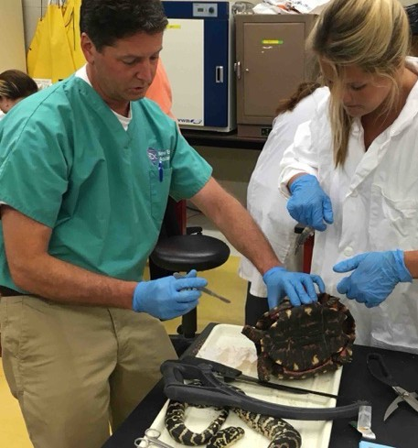
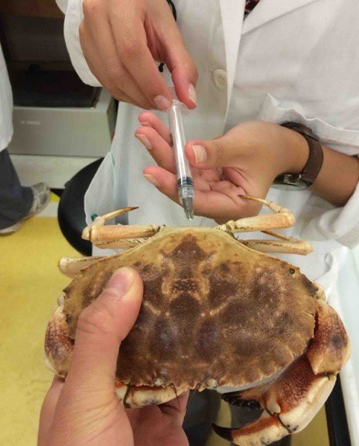
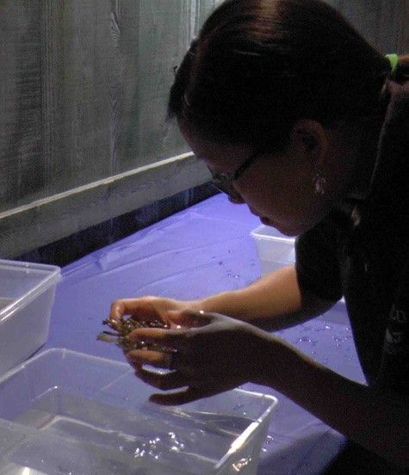
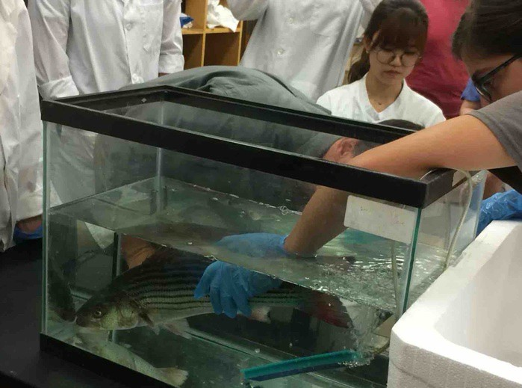
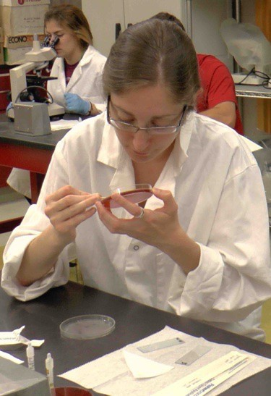
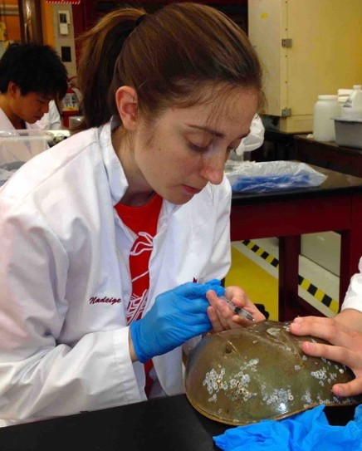
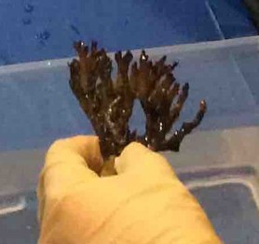

Scenes from AQUAVET® I

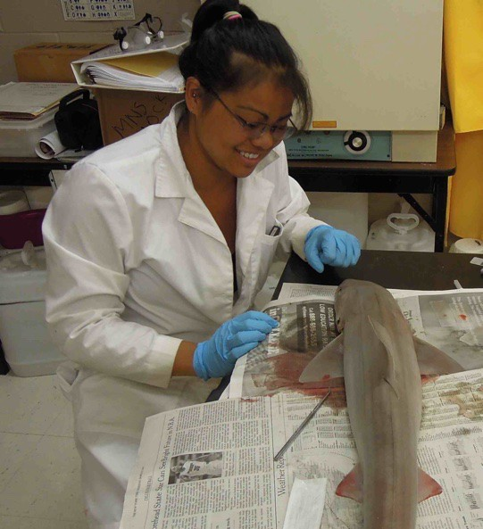
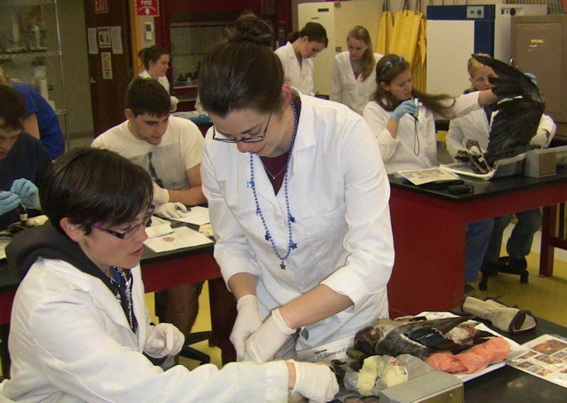
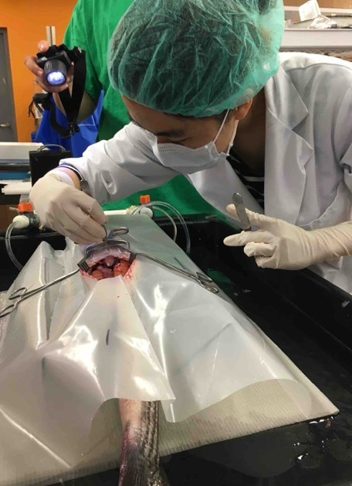
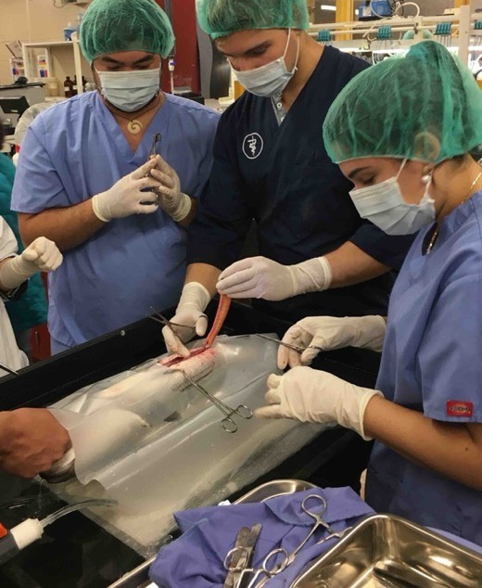
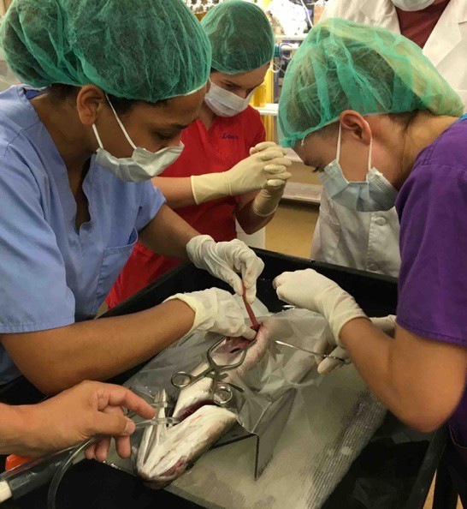

Scenes from AQUAVET® I

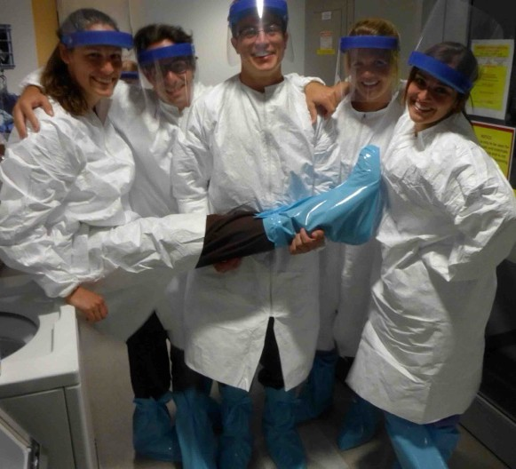
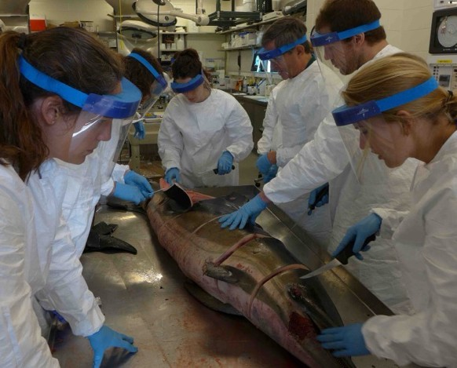
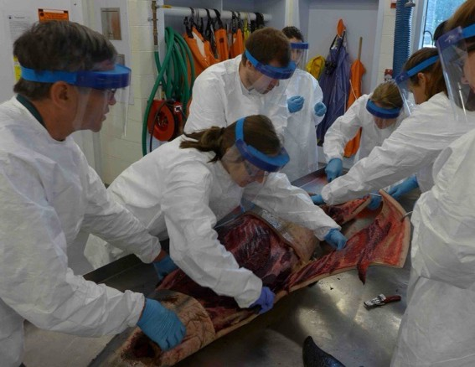
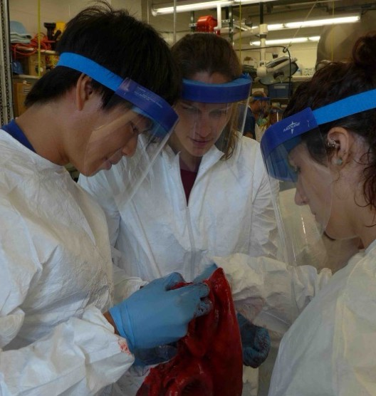
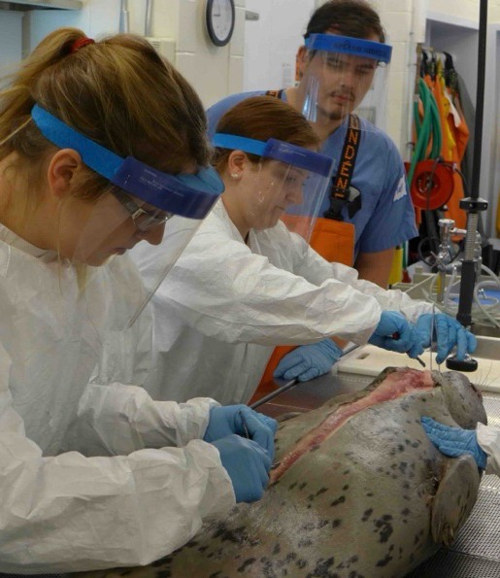
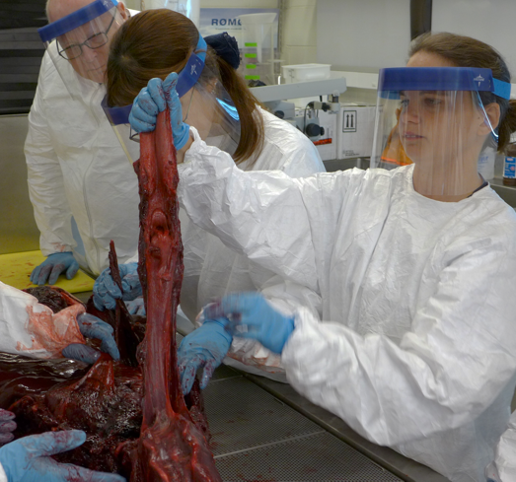

Scenes from AQUAVET® I
(photos – Robert Maze)

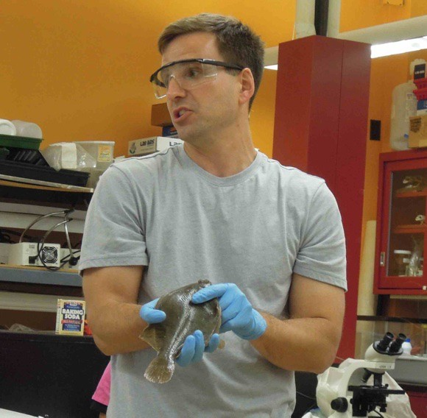
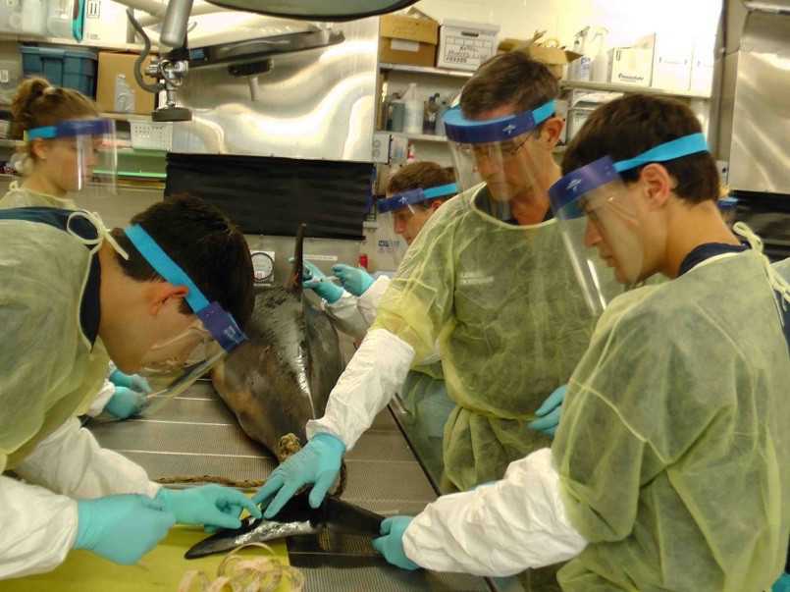
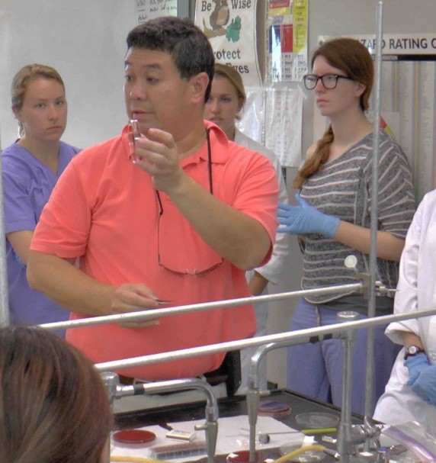
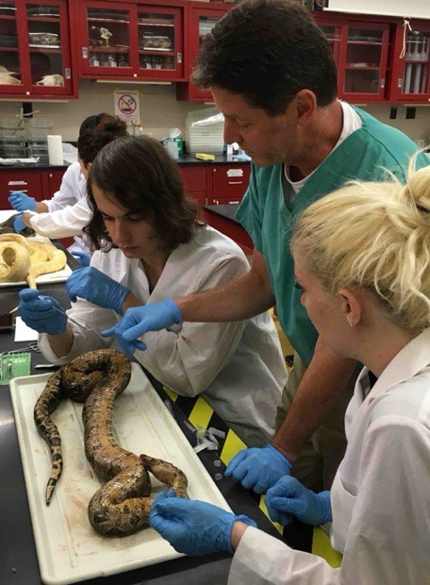
S T U D E N T S

&

F A C U L T Y

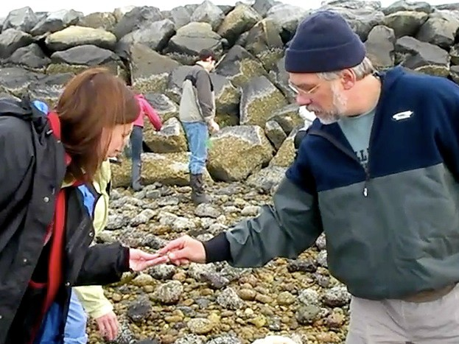
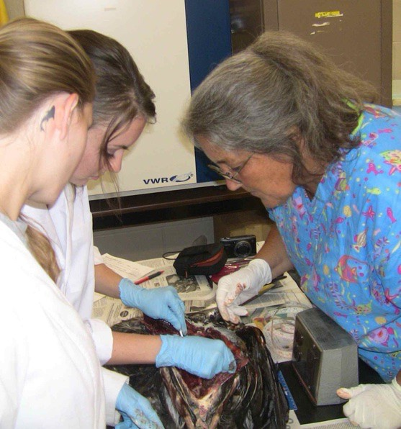
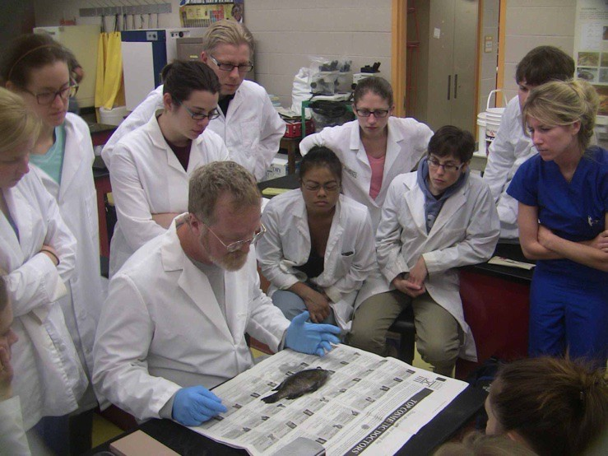
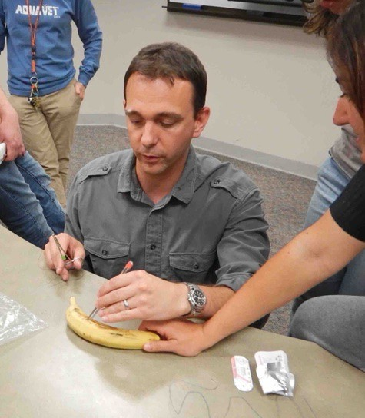
S T U D E N T S

&

F A C U L T Y

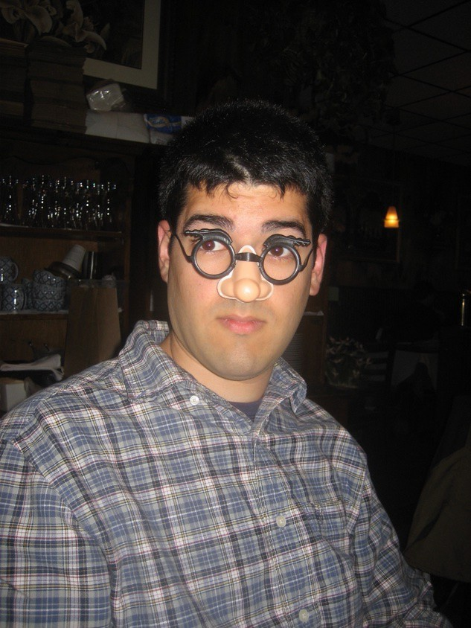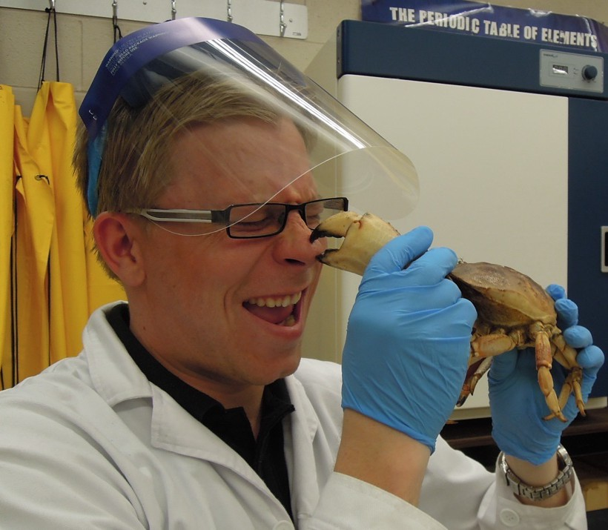

Not All Fun and Games

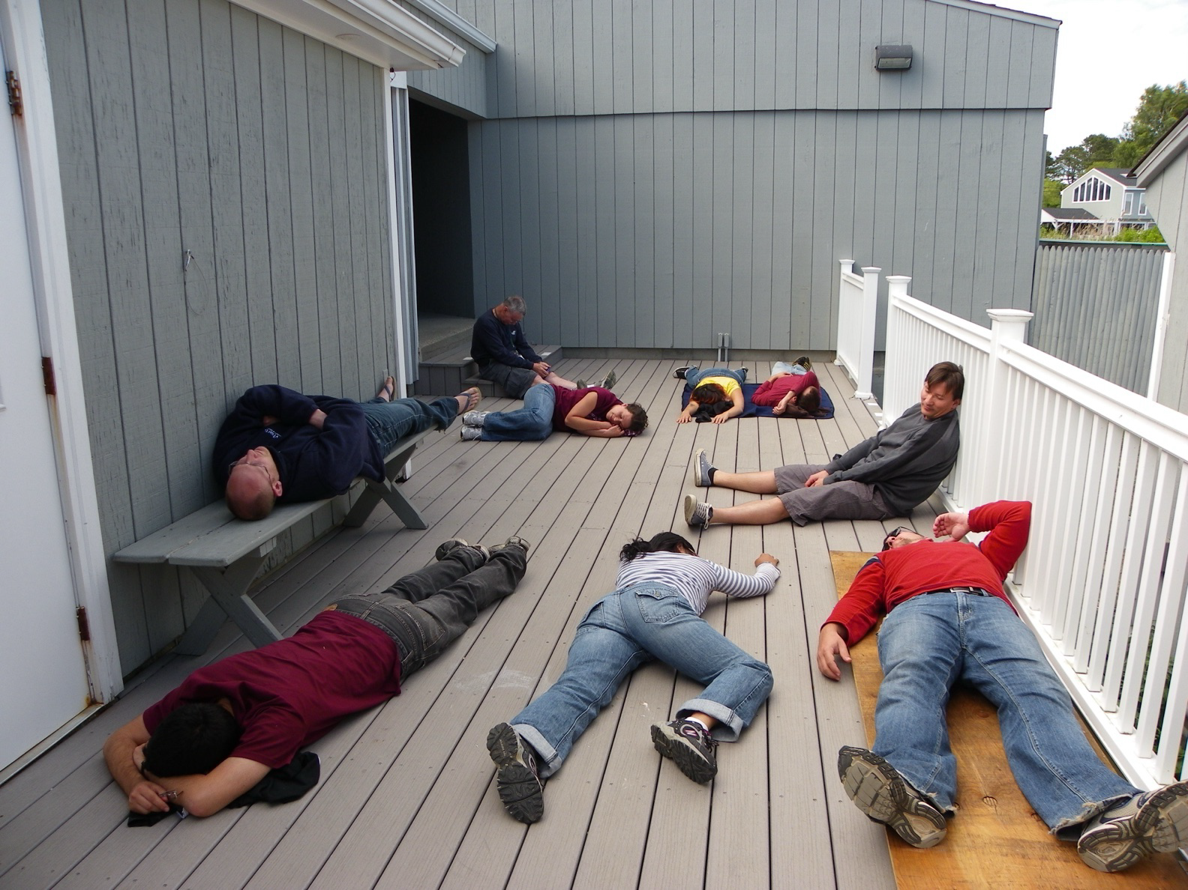
- Classes
  - routinely 5.5 to 6 days a week
  - (and most evenings)
  - Required to Attend Class

  - 8 am to noon
  - 1 pm to 5 pm
  - 6:30 pm to 8:30 pm or later

AQUAVET® I








- Student seminars
  - 25-30 minute
  - PowerPoint
  - Topics
    - Invertebrates to marine mammals
    - Marine plants
    - Ecology
  - prepare early

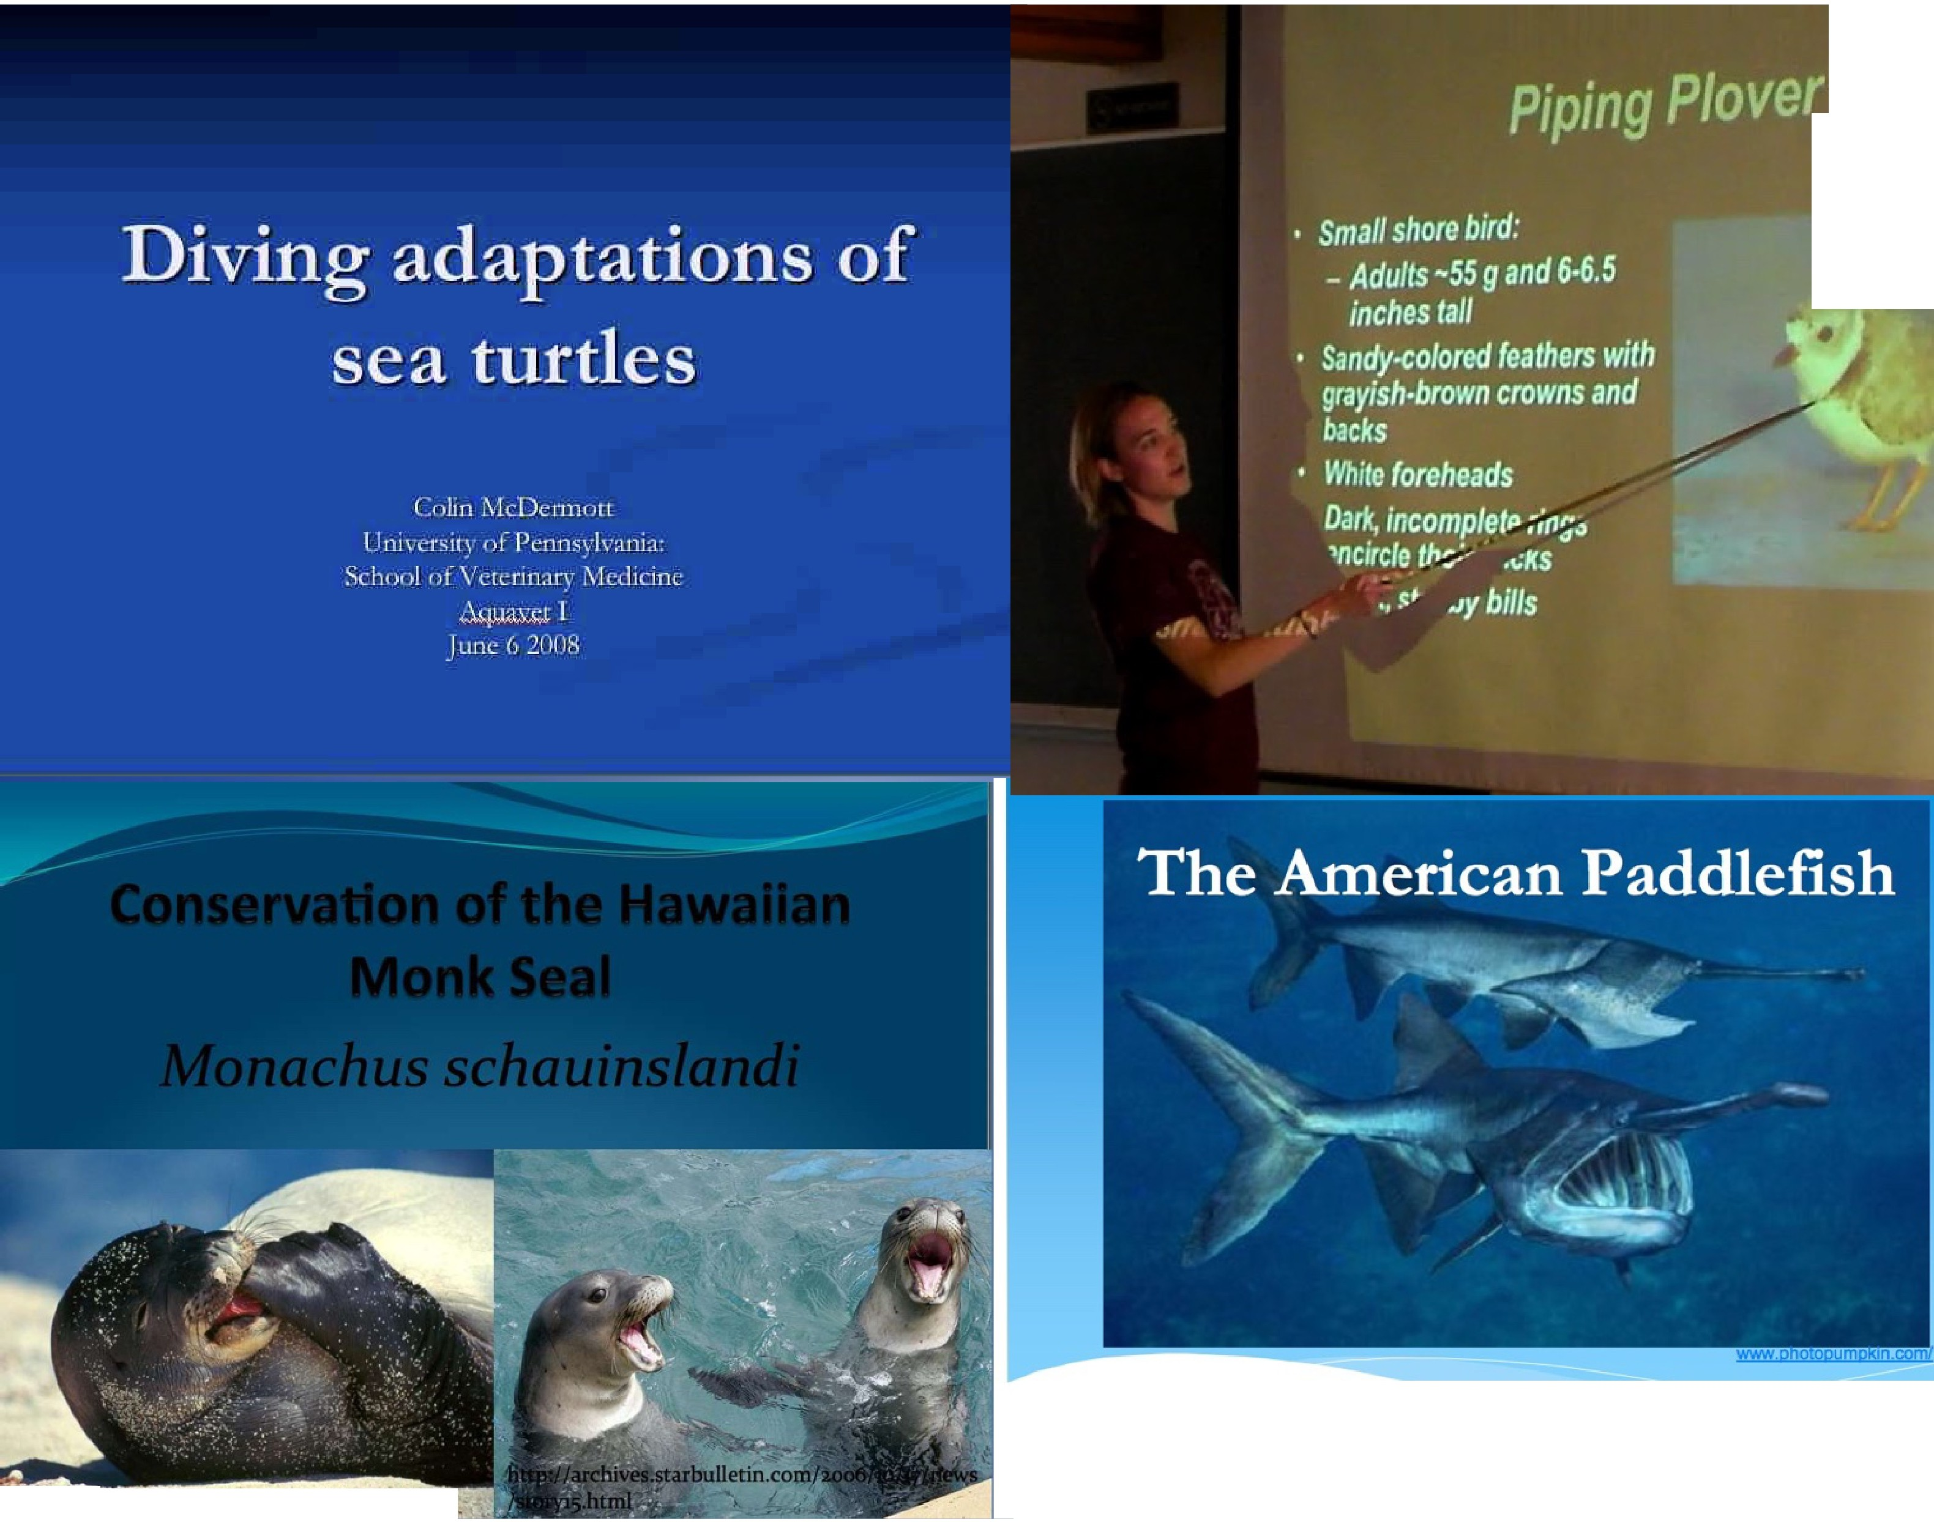

4hhp:/ /www.kauaimonklieal.com/Home.html Past, Present and Future Ari [ust;ulsjian

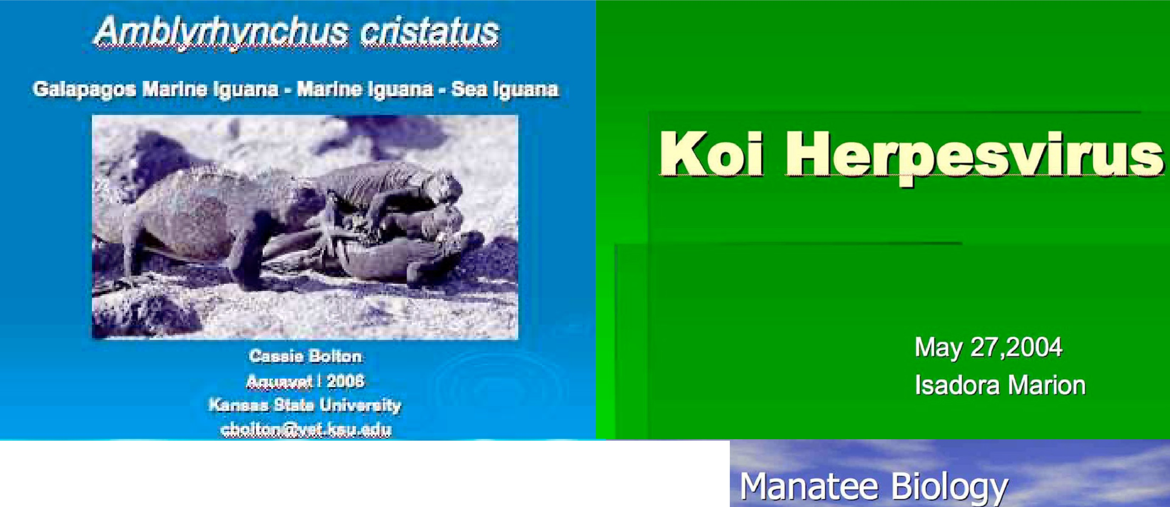
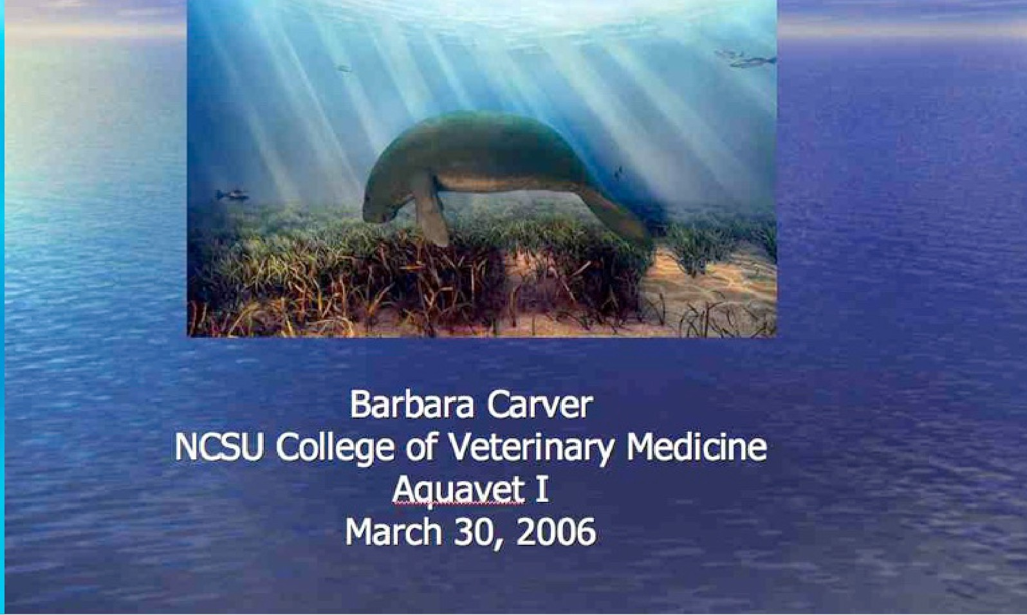
Naf.wrral ltlisfa� afi the

Presented by
Alexandra Outl0w, D.V.M.

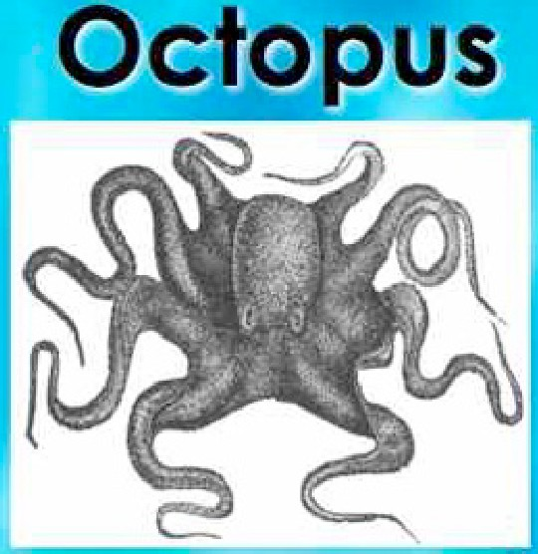

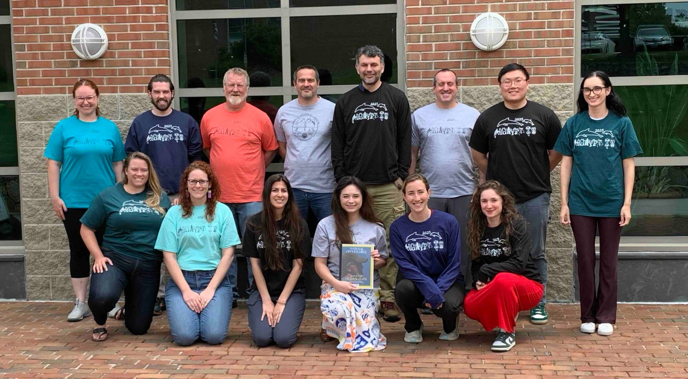


AQUAVET®
Comparative Pathology of Aquatic Animals
II


FOCUS



Pathology and Pathogenesis of diseases
- of important
aquatic invertebrates and fish
- biomedical research models
- cultured species

AQUAVET®
Comparative Pathology of Aquatic Animals
II



- Prerequisites: AQUAVET® I or equivalent
- Two Weeks – May 25 to June 7, 2026
- Classes 6 days a week and most evenings




- Lectures, slide review, and occasional wet labs
  - Primarily Fish and Invertebrates
  - Comparative Anatomy
  - Parasites
  - Bacterial, Viral and Fungal Diseases
  - Toxicology
  - Histopathology


AQUAVET® II



- Student Tuition - $2,010
  - Includes course instruction and room and board


- Required to Attend Classes
  - Foundation covering 2/3 of cost


- Course Credit possible
  - Depends on school requirements



- Evaluation
  - Based on class participation

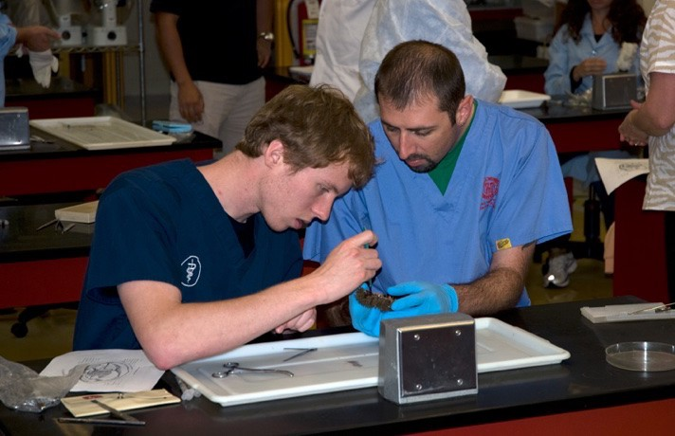
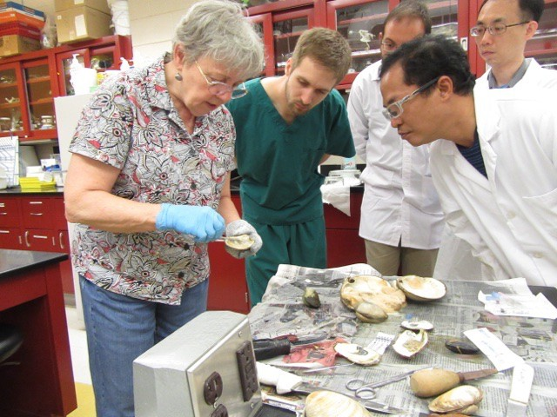
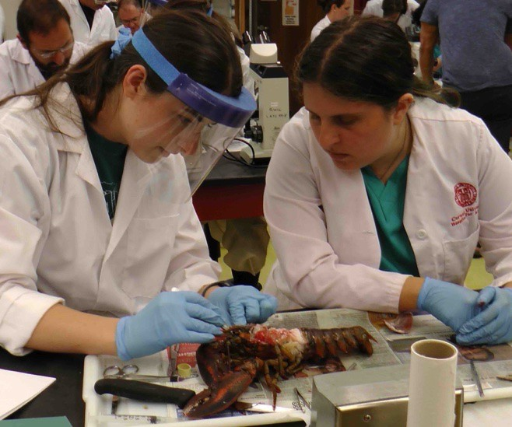
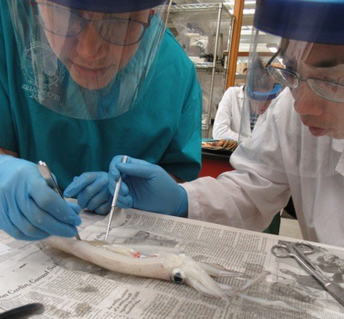
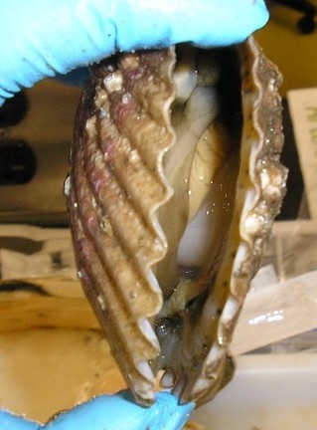

Scenes from AQUAVET® II

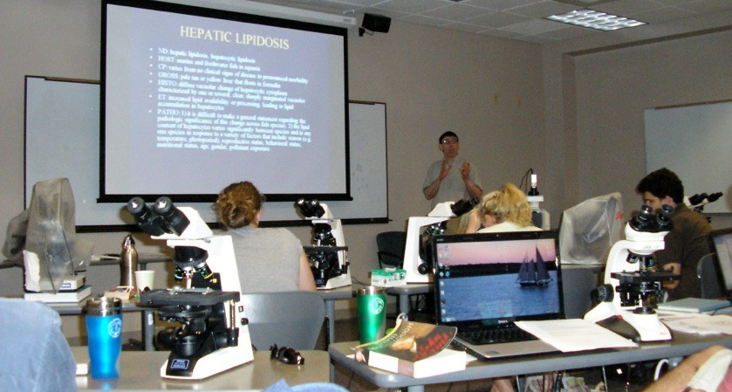
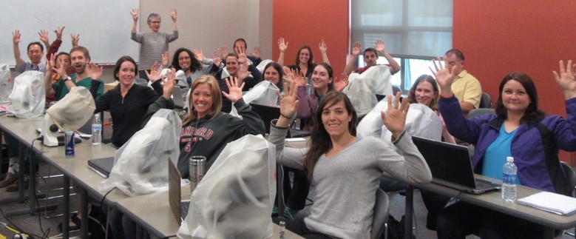
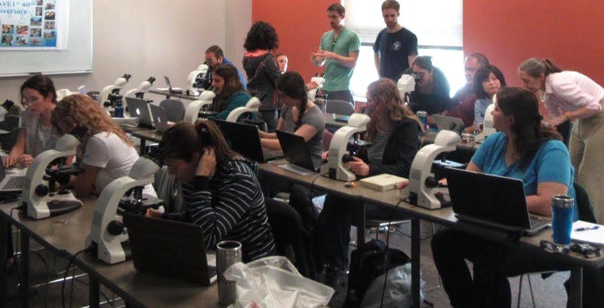
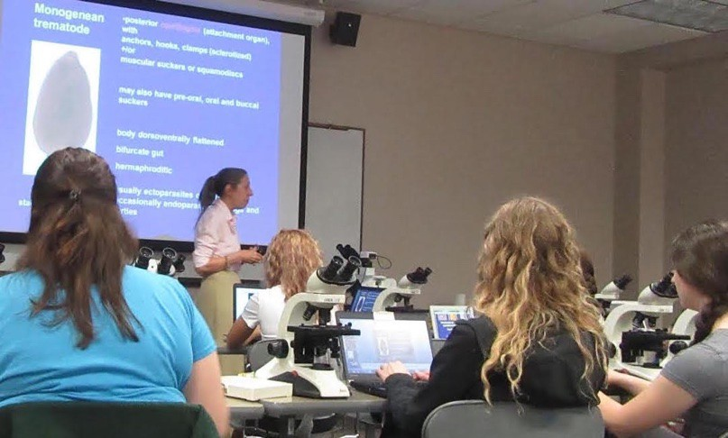
AQUAVET® II - Lots of Microscope Work

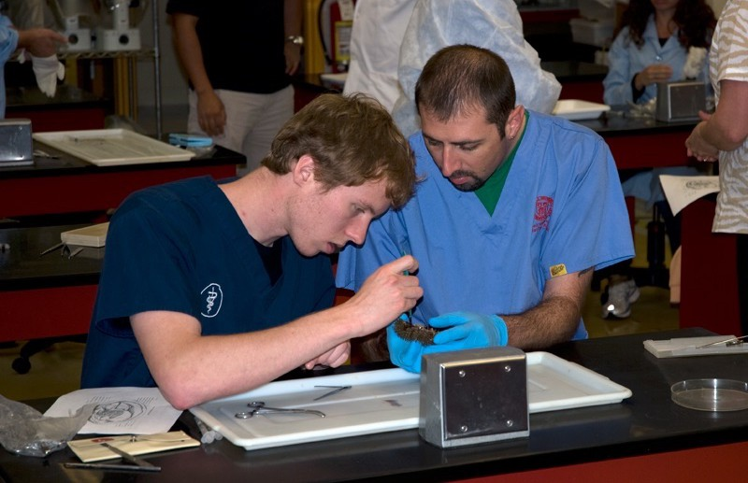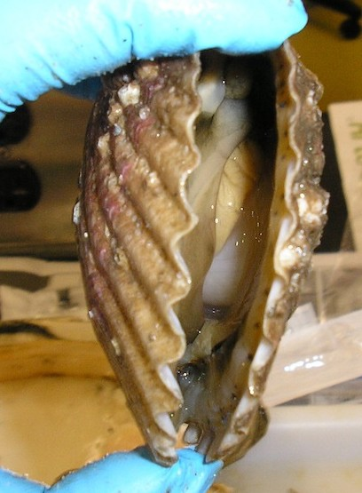

Several Wet Labs in AQUAVET® II

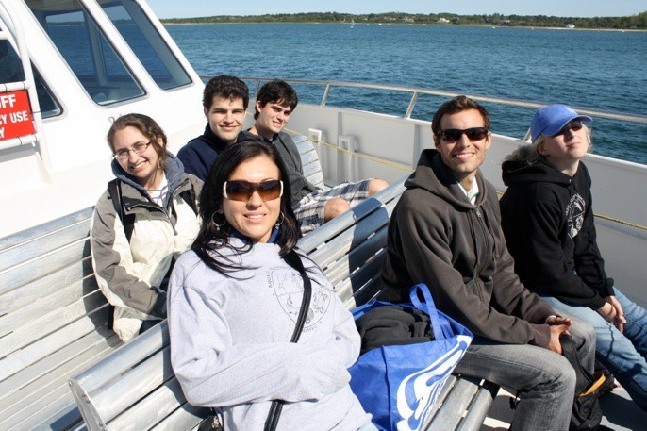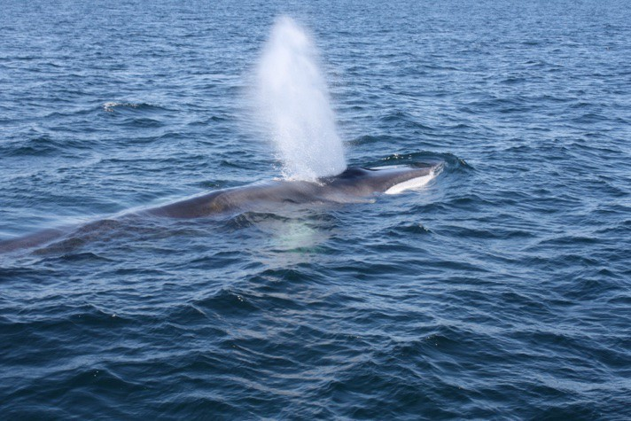

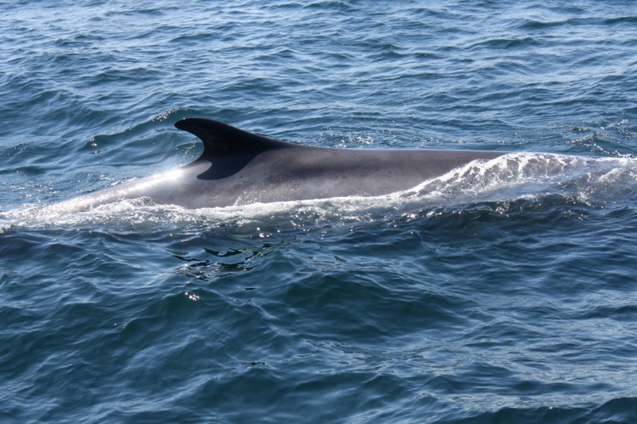
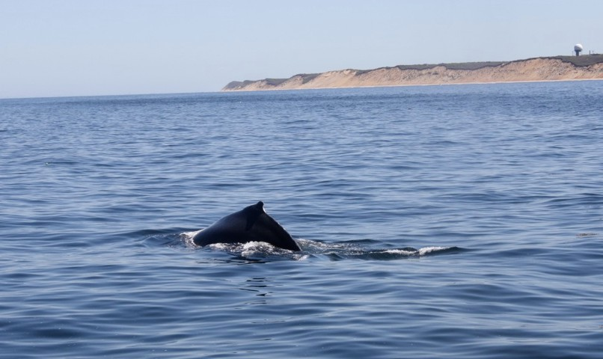
Whale Watch
Finback Whale

Humpback Whale

Finback Whale

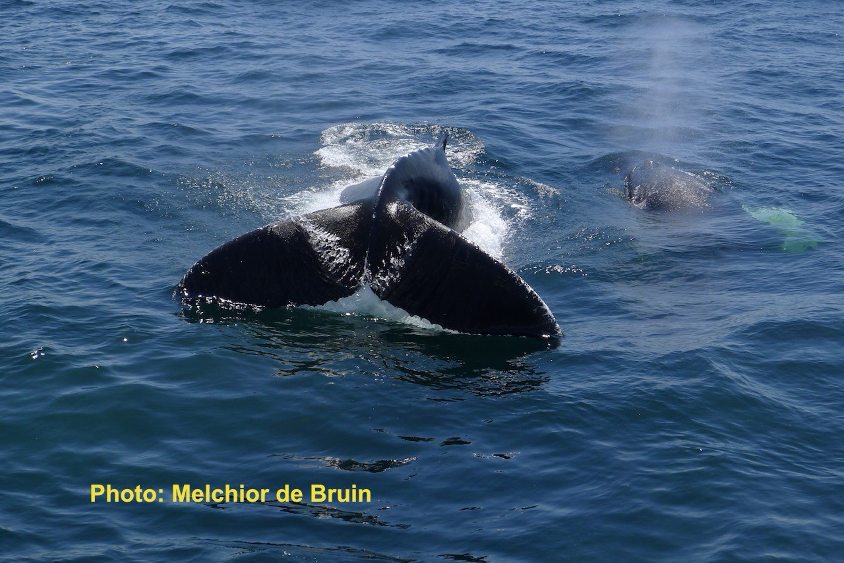

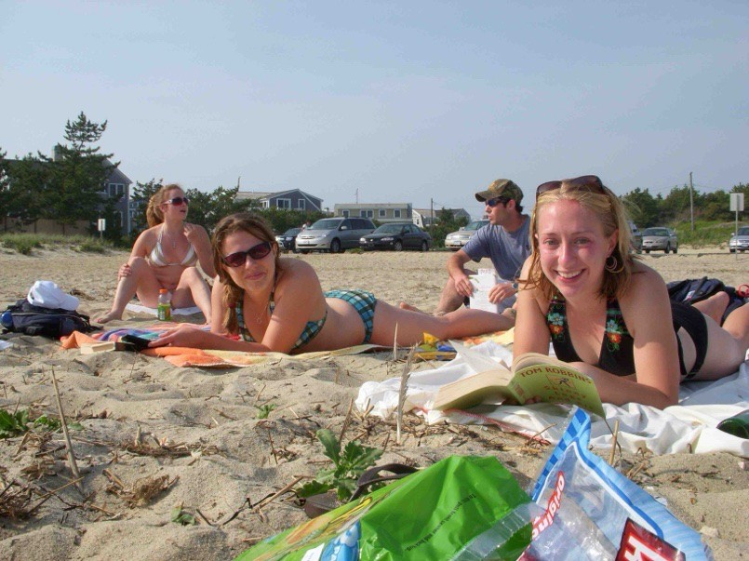
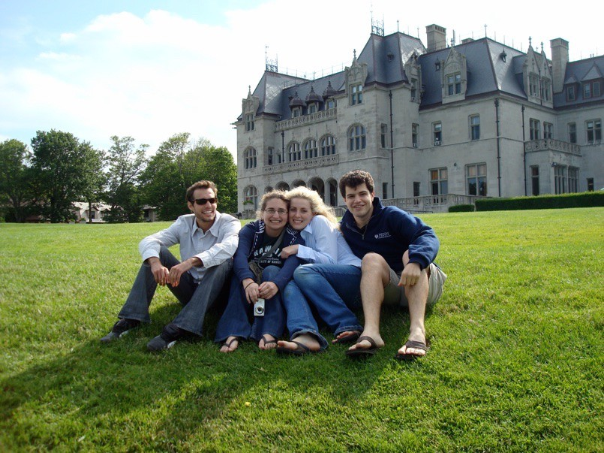
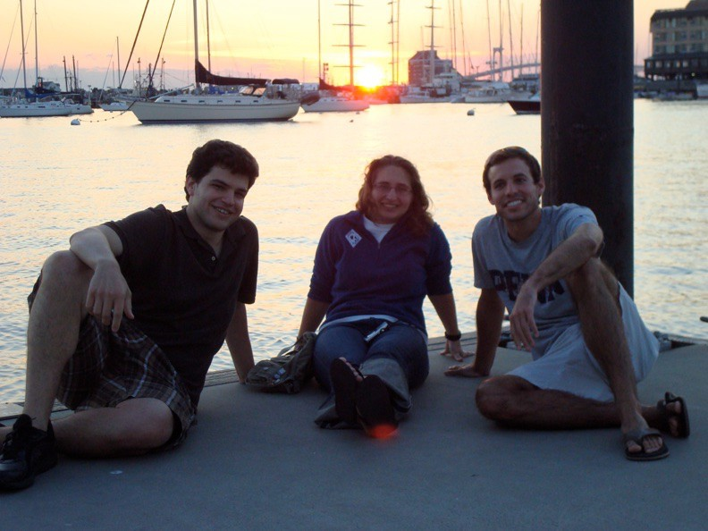
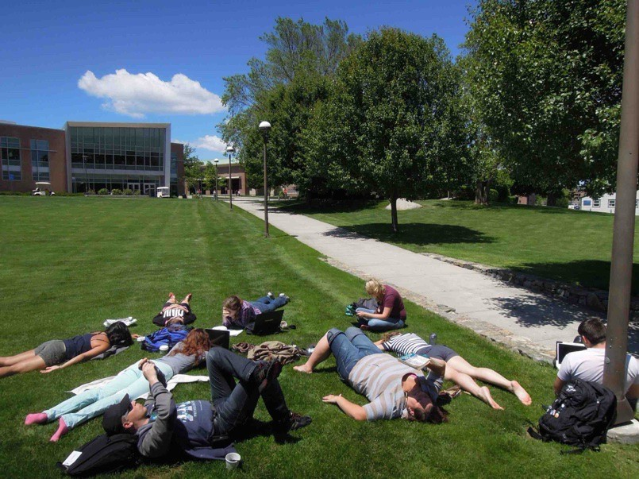

Free Time

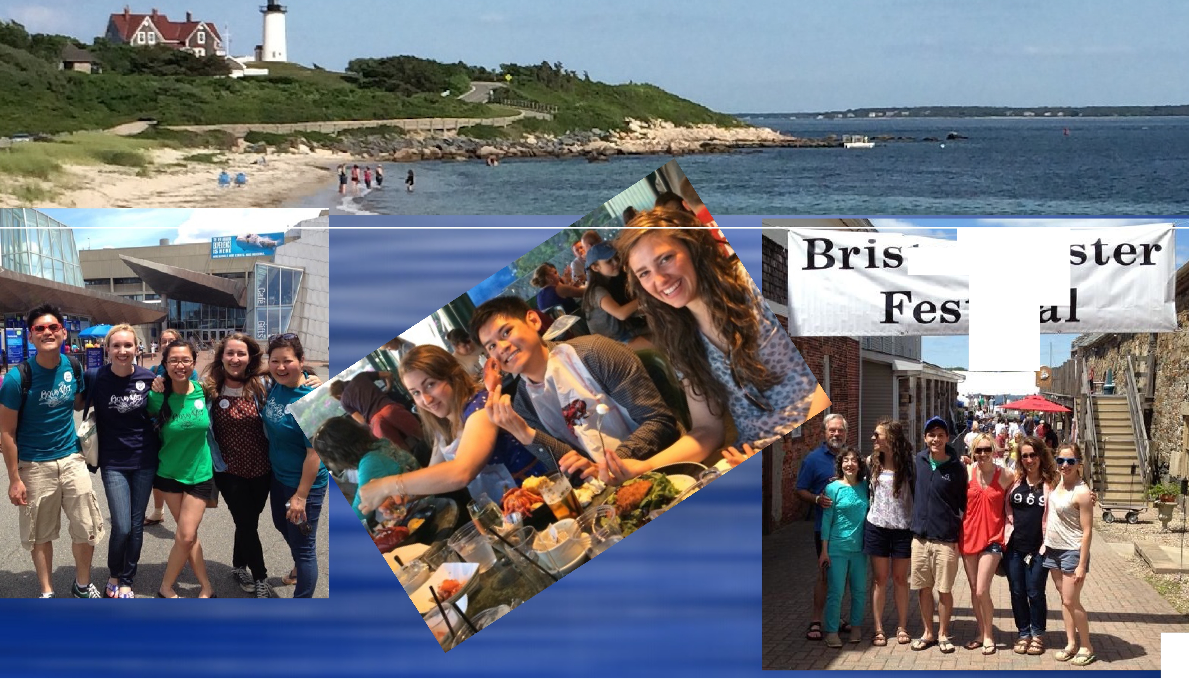

tol Oy
tiv

' ....


AQUAVET® Summer Fellowship



- Research project under guidance of AQUAVET® faculty
- 8 week duration (July and August)
- Aquaculture Based Project (funding requirement)
- Limited positions – usually 1
- Pays stipend of $3,800 after finishing all 8 weeks
- Publication often generated at the end of project

APPLICATION PROCESS



Application forms
www.aquavet.org


Down-load the application form
MS Word and pdf



Please Submit Electronically



APPLICATIONS DUE 15 Jan

APPLICATION PROCESS


What you must submit:

- The completed application form
- OFFICIAL Undergraduate transcripts
- OFFICIAL Veterinary school transcripts
- Current CV (Curriculum Vitae)

NOTE: “OFFICIAL” means they are sent directly to the director by the university. We cannot accept transcripts sent by the students. Most are done electronically these days.

APPLICATION PROCESS





NOTES:
- If applying for more than one course, need to submit application for each, however, only one set of transcripts
- If applying for a second year (e.g. AQV2 or AQV3), only the updated veterinary school transcript is required (and application)
- Veterinary school transcript must include recent work (fall of the year before application due)
- CV now also required
- Letters of recommendation accepted but NOT required
- Transcripts must be official copies sent directly to the director
  - Transcripts should be sent electronically by the university to the director
  - Paper transcripts are problematic, but IF NECESSARY will be accepted at director’s address

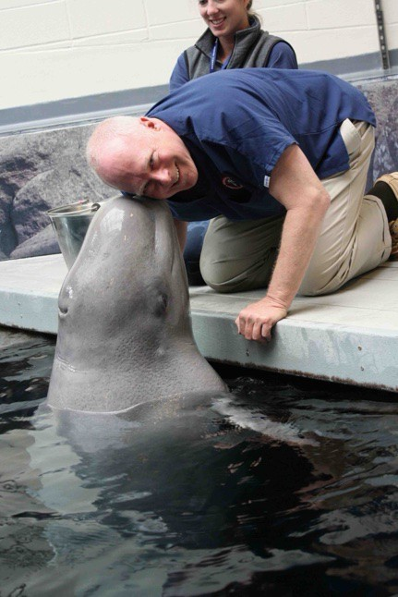
APPLICATION PROCESS


Where to submit:



Should be electronic: aquavetmail@gmail.com








If transcripts must be sent by mail:
Donald W. Stremme, V.M.D. AQUAVET® Director
Public and Ecosystem Health College of Veterinary Medicine Cornell University
930 Campus Road
Ithaca, NY 14853

APPLICATION PROCESS



- Applications due January 15th



- Application forms - website
  - Via E-mail as PDF file preferred


- Essay - highlight any aquatic experience
  - Can be separate word document
  - This is most important part of your application




- Acceptance to the program
  - Competitive Basis
  - Announced in February

APPLICATION PROCESS
The application process is competitive
What does the admission committee look for?
An indication that you will use the information in the future
What have you done in the past in the aquatic sciences and/or aquatic animal medicine…..
and/or even other exotic animal work Formal courses
Other courses
Paid and volunteer work experience Other: e.g. hobbies (keep aquarium fish)
Membership: IAAAM, WAVMA, AAFV, AAZV, ARAV, etc.


Application form, essay –
Why you think you will benefit from the course. Probably the most important part of the application. Follow the instructions regarding length of your essay. Proof read it.

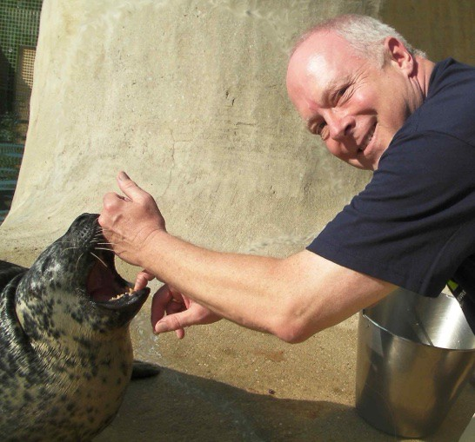

Further information


- Website www.aquavet.org
- Contact Information




Donald W. Stremme, VMD (609) 350-3044
aquavetmail@gmail.com

