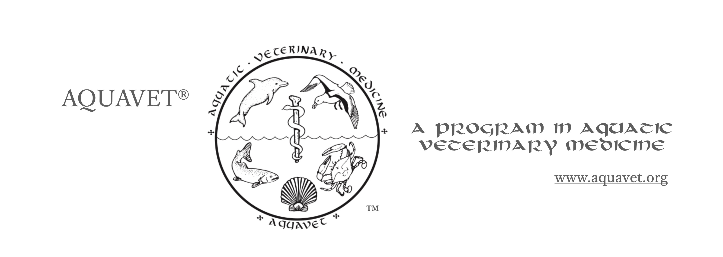

Application for Admission to

AQUAVET®I - Introduction to Aquatic Veterinary Medicine
With or without Summer Research Fellowship

AQUAVET® I application requires submitting these things:
- Completed application
- Current CV (Curriculum Vitae)
- OFFICIAL transcripts of all college-level training (undergraduate and veterinary school – also any graduate school you might have taken).

“OFFICIAL” means they must be sent directly to the director from the university (electronically if possible). Students not from North America should contact the
director to inquire about options.

These items must be received no later than January 15th.
Electronic submission is required for the application and preferred for the transcripts.

NOTE: If you applied in the past for any of the AQUAVET courses, you only need to supply the updated transcripts along with this application and CV.

Only if transcripts cannot be submitted electronically, OFFICIAL copies can be mailed here (to be received by January 15th). All electronic materials should be sent to the email below.

Donald W. Stremme, V.M.D.
AQUAVET® Director
Cornell University
College of Veterinary Medicine
Microbiology and Immunology
C5181 Vet Medical Center
Ithaca, NY 14853

aquavetmail@gmail.com
609-350-3044

The director will acknowledge receipt of your applications materials.
If you have not had a response, they might not have been received.

Notice of admissions decisions will be sent by March 1.
1. Summer Research Fellowship

Submission of this application indicates you are applying for
AQUAVET®I - Introduction to Aquatic Veterinary Medicine

You may also apply for the summer research fellowship, which is open only to students who have taken or are taking AQUAVET®I. It is an 8-week fellowship following AQUAVET®I or II that includes a stipend for costs.

If interested in applying for the summer research fellowship, please indicate that here:
Summer Research YES / NO

Research projects are often predetermined by the AQUAVET directors so that the student can step right into the project, however, if you have a particular research interest, please discuss it here. We will also consider that should you be chosen.

2. Personal Data

NAME
Title (Ms, Miss, Mrs, Mr, Dr, Prof):

Last:

Middle Name or Initial (not required):

First:

E-MAIL
Preferred:

Long-term (still good in 10 years):

Other:

PHONE
Mobile:

Other (indicate if office, home, etc.):

CURRENT mailing address:

Permanent address (where you can be reached in 10 years), if different from above:

Current academic curriculum or position

If employed (indicate where): ______________________________________________

Degrees Awarded: ______________________________________________

If in school indicate:

Class of (indicate year): ___________

Planned end of internship/residency (year): ___________

3. Education and Training

Be sure your educational and professional training are clearly indicated on your CV.

It is also helpful for the admissions committee, if you highlight which undergraduate, graduate or veterinary courses you have taken relating to exotics, wildlife or aquatics. List them below; we will look for these on your transcripts. If more space is needed, list these on a separate document.

NOTE: If you are not in veterinary school and not a graduate veterinarian, please be sure to indicate what specific courses/training you have that has prepared you to handle the AQUAVET course material (e.g. histology, pathology, toxicology, etc.). The syllabus from the past year can be found on the website.

4. Summary of Goals and Motivations

Please submit a statement, between 250-400 words in length, expressing the basis for your interest in aquatic veterinary medicine. Include past or current events that have contributed to the interest such as education, work, or other experiences relevant to marine and/or fresh water biology, aquatic veterinary medicine, or related fields. Be as specific as possible in describing your currently recognized career goals and the reasoning that led to them. NOTE: You may submit this as a separate document, but must keep the word count under 400. Also, you may not use the word “passion” or any of its derivatives.

Cornell University is an equal opportunity affirmative action educator and admits students of any race, color, sex, religion and national and ethnic origin, and students who may be handicapped or disabled.

