This document is a template to assist the Biosecurity Manager in developing an operation-specific, enhanced biosecurity plan for their premises. Each item from the Secure Beef Supply Plan Self-Assessment Checklist for Enhanced Biosecurity for FMD Prevention: Beef Feedlots OR Cattle on Pasture is included. The Biosecurity Manager should keep all items that apply to the operation, modify them by replacing the [example text] with information specific to the operation, and delete information that does not apply as well as all highlighted text. A labeled premises map must be included in this plan. Standard Operating Procedures (SOPs) may also be needed and should be available on the operation, but do NOT need to be included in this written biosecurity plan.
NOTE: This document was updated in January 2021 to include the following:
- Where applicable – Position Titles instead of Names
- Section 5. Entry Log instead of Logbook
- Section 6. Animal Movement: Loading/Unloading Animals –new options to prevent exposure risk from livestock trailers, diagrams
- Section 7. Carcass disposal – requesting movement permits for carcasses
- Premises Map – label animal housing, feed, other structures
INSTRUCTION PAGE FOR ENHANCED BIOSECURITY PLAN FOR FMD PREVENTION TEMPLATE
To be deleted

[Name of Operation] Enhanced Biosecurity Plan for FMD Prevention in [State]
Updated: [Date created or updated]
This Biosecurity Plan is based on the Secure Beef Supply (SBS) Plan Self-Assessment Checklist for Enhanced Biosecurity, [Beef Feedlot October 2020 or Cattle on Pasture October 2020] and was developed using guidance from the SBS Information Manual for Enhanced Biosecurity for FMD Prevention: Beef Feedlots or Cattle on Pasture. All documents are available at www.securebeef.org. In our plan below, all items have been implemented except those indicated which will be implemented prior to requesting an animal movement permit.

Scope of Biosecurity Plan
Describe the Premises:
- National Premises Identification Number (Prem ID or PIN): [PIN] (request from the office of the State Animal Health Official)
- Premises Address: [a valid 911 Address where animals reside]
- Premises GPS Coordinates: [Latitude, Longitude of entrance to livestock area]
- Animals* on primary premises: [All Species] and [Average or Range of Number of animals]
- Animal housing types: [e.g., buildings, pastures, dry lots]
- Other business operations on premises? [Yes or No]
If yes, what? [e.g. vegetable stand; sale of feed, fertilizer, or compost; hosting farm tours, Retail Store]
- Secondary premises** locations: [list the PINs, 911 addresses, or GPS coordinates (latitude, longitude) where animals associated with this operation reside (e.g., affiliated operations, pastures)]
  - Will be provided if this premises is located in an FMD Control Area
*Animals that are susceptible to FMD include cattle, pigs, sheep and goats. For biosecurity guidance for dairy cattle and pigs, see www.securemilksupply.org, pigs see and www.securepork.org and sheep see www.securesheepwool.org.
**Work with your State Animal Health Official to determine if separate PINs are needed for all of your associated premises.

Biosecurity Manager and Written Plan
The designated Biosecurity Manager for this premises and their contact information follows:
NAME:
PHONE: [xxx-xxx-xxxx]
EMAIL: [email address]
In the event the Biosecurity Manager is away from the operation, their designee’s contact information is:
NAME:
PHONE: [xxx-xxx-xxxx]
EMAIL: [email address]
The Biosecurity Manager’s contact information is posted [describe where located].
[Person One Name] and [Person Two Name] have the written authority to ensure compliance with biosecurity protocols and take corrective action as needed.
[Name] developed the operation-specific biosecurity plan with the assistance of (keep all that apply):
- [Name], a licensed veterinarian whose contact information is:
PHONE: [xxx-xxx-xxxx]
EMAIL: [email address]
- [Name], a consultant with [Name of Company] whose contact information is:
PHONE: [xxx-xxx-xxxx]
EMAIL: [email address]
The Biosecurity Manager or their designee (check all that apply):
☐ communicates with and/or trains individuals entering the premises on biosecurity measures to follow;
☐ reviews the biosecurity plan at least annually and updates it whenever the operation goes through a change affecting biosecurity;
☐ ensures that all individuals entering the operation frequently (weekly or more often) have access to a copy of the biosecurity plan; and
☐ is capable of implementing the written plan if FMD is diagnosed in the U.S.
A labeled premises map is included at the end of this plan and can be found on the premises at: [describe where].

Training
The people in the positions listed below are trained at least [biannually, annually] about the biosecurity measures necessary to keep FMD out of the herd. This training is documented and available for review upon request.
☐ [Describe positions: Owners,
☐ Biosecurity Managers,
☐ Essential Personnel]
The Biosecurity Manager(s) informs individuals entering the operation of the biosecurity measures they are to follow in a language they understand. Individuals are aware of the biosecurity concepts and procedures that apply to their specific areas of responsibility. Our required training is described below.
All individuals entering must understand how to:
☐ Contact the Biosecurity Manager(s)
☐ Respect the Line of Separation (LOS)
☐ Cross the LOS, if required, following arrival and biosecure entry requirements
☐ Perform biosecurity measures for their specific job duties
Essential personnel must also:
☐ Understand the importance of biosecurity;
☐ Review the entire biosecurity plan;
☐ Review the labeled premises map;
☐ Know who to report to if they see someone not complying or something preventing compliance; and
☐ Recognize the consequences for not complying with biosecurity protocols.

Protecting the Operation

Line of Separation (LOS)
The Line of Separation is labeled on the premises map at the end of this plan. The LOS is marked on-site with [describe (e.g. fencing and/or a rope between marked poles)].
Cattle do not have access to other livestock, streams, waterways, or run-off water or organic matter that may have come from other premises.

LOS Access Point(s)
Entry to the operation is restricted to [number] controlled LOS Access Point(s) and each are labeled on the premises map at the end of this plan. The LOS Access Points are clearly marked with a suitable barrier of [Describe barriers such as gates, ropes or cables] to restrict entry. Unused driveways that are not LOS Access Points are protected with [describe barriers such as gates, hay bales, trucks, etc.] to prevent vehicles and people from entering.
Signs written in [list languages provided] are posted at all LOS Access Points that include (delete what does not apply) [Biosecurity Manager’s phone number; biosecurity protocols for entering; where to find biosecurity protocols for entering].
All movements (animals, vehicles, equipment, people) across the LOS are recorded and these documents are kept in the [describe where] and are available for review upon request.
The designated animal loading/unloading area(s) is/are labeled on the premises map at the end of this plan and this is NOT used for a people entry point.
Deliveries not essential to the operation are made outside of the LOS at the [describe where] and this area is indicated on the premises map and signage posted at the LOS Access Point.
Vehicles crossing through the LOS Access Points are cleaned to remove visible contamination and then disinfected at the Cleaning and Disinfection Station.
People and items crossing through the LOS Access Points follow appropriate specific biosecurity steps, described under Biosecure Entry Procedure in this plan.

Cleaning and Disinfection (C&D) Station
There is an operational, clearly marked, and equipped C&D station(s) located [describe where] and it is labeled on the premises map at the end of this plan. The wash pad for the C&D station is made of [describe the surface – paved, gravel, plastic lined] and slopes away from animal housing, feed receiving or storage areas, waterways, and on-farm traffic areas. This operation uses [drainage ditches, berms, or other physical barriers] to manage effluent from the C&D area to ensure susceptible animals are not exposed. Effluent from the C&D Station is managed following all state and local regulations.
This operation has access to all the equipment and supplies needed to successfully operate the C&D Station. The SOP for the C&D process is available upon request.
The following individuals have received documented training in proper selection and use of personal protective equipment, the principles of C&D to avoid introducing FMD virus to the operation, and area able to effectively operate the C&D Station.
- [Name or Position Title]
- [Name or Position Title]
In the case of inclement weather (freezing temperatures, thunderstorms, high winds) when the C&D Station cannot be operated, we have the following contingency plans to ensure vehicles do not bring visible contamination onto our operation:
- [Describe alternatives; many examples exist in the Information Manual].

Designated Parking Area
The designated parking area is clearly marked with [ropes, signs, etc.] and labeled on the premises map at the end of this plan. It is located outside of the LOS and away from animal areas.

Maximize Distance between Susceptible Livestock on Adjacent Premises
(From Cattle on Pasture – delete what does not apply)
The distance between susceptible livestock on adjacent premises and this premises is [describe how far and label the units – feet, miles, etc.]. The steps to increase distance in an outbreak include [describe] and have been coordinated with owners/operators of these premises to limit disease exposure.

Grazing Public Lands
(Pick one, delete the other)
☐ This operation does not access or use public lands for grazing.
OR
☐ Our cattle graze public lands [List months of the year]. We [are/are not] part of a grazing association. Cattle are moved to the public lands using (check all that apply):
☐ Common use roads
☐ Common use corrals/trailheads
☐ Common use trail systems
We recognize shared lands can pose exposure risks from other livestock, wildlife, and people accessing public lands during an FMD outbreak. We have worked with our State Animal Health Official and livestock association to develop proposals for livestock separation and movement strategies on public land allotments. These steps include [describe ]

Vehicles and Equipment

Vehicles and Equipment (non-animal transport)
All vehicles and equipment (not containing live animals) are cleaned to remove visible contamination and effectively disinfected prior to crossing the LOS; otherwise entry is prohibited.

Harvest and Feed Delivery Equipment (pick one, delete the other)
☐ Freshly harvested crops are not delivered to this operation;
OR
☐ A plan is in place to temporarily modify the LOS to create a direct path to the feed storage area for harvest vehicles/equipment that may be transporting feedstuffs during harvest of [List crops (e.g., silage, haylage, hay, small grains, etc.)]. This route is NOT used by vehicles inside the LOS to feed or contact animals. We are able to access this feed storage area from another direction that does NOT cross paths. Visible material on tires/undercarriage will be removed prior to entering the premises, with every effort made to not spray the feedstuffs (hay, silage, grain) carried by the vehicle. Once visible material has been removed, the harvest vehicles/equipment drive directly to the feed storage area. The drive path is cleaned and disinfected after harvest/feed delivery is complete, ensuring run-off/effluent does not enter animal housing, waterways, or traffic areas within the LOS. Once the area is C&D, the LOS is re-established as it was prior to harvest.

Livestock Trucks/Trailers (animal transport vehicles)
All empty animal transport vehicles are cleaned and disinfected prior to arrival at the operation (outgoing loads) or before animals are loaded for delivery to the operation (incoming loads).
Occupied animal transport vehicles are not allowed to cross the LOS. (Mark all that apply)
☐ Gates are installed to safely move livestock onto the operation from the livestock trailer.
☐ On-farm livestock trailers are used to transport animals to or away from the arriving livestock trailer at a designated cattle crossing LOS Access Point.

Personnel

Prior to Arriving at the Operation
The Biosecurity Manager ensure that everyone crossing the LOS on foot or exiting their vehicle inside the LOS has been instructed to arrive at the operation
- with a clean vehicle interior (free of all animal manure/excrement) that has not become contaminated by soiled clothes, footwear, or other items
- having showered and wearing clean clothing and footwear since last contacting susceptible animals.
  - For individuals that work with animals and live on-site, showering and changing into clean clothing/footwear before leaving the house is required.
  - For individuals living off-site, after showering and changing into clean clothes and footwear, they must NOT contact animals, live or dead, or facilities where they are held prior to arrival at the operation.
Essential personnel who will need to cross the LOS during an FMD outbreak include:
- List essential positions [e.g., cowboys, herdsman, feeder, veterinarian, etc.]
- List essential positions
- List essential positions
These individuals have a signed Employee and Visitor Arrival Agreement on file agreeing to follow our biosecure entry procedures (described below).

Entry Log
Everyone crossing the LOS Access Point(s) completes the entry log, which is located [location], unless they are a scheduled worker.
The entry log is monitored by [individual responsible] on the operation to ensure accurate completion.
The contact information and work schedule records for all workers are maintained and posted [location].

Biosecure Entry Procedure
All individuals crossing the LOS on this operation must:
- Wear operation-dedicated footwear, OR
- Wear disposable or disinfectable footwear; AND
- Ensure hands are clean
  - Wash hands and/or
  - Wear disposable or disinfectable gloves over clean hands
- All animal handlers must also put on operation -dedicated clothing OR put on clean coveralls/protective outerwear
Biosecure Exit Procedure
Individuals crossing the LOS to the non-cattle side must exit through the [describe location] and remove protective outerwear, disposable footwear, and gloves. Hands may be washed [A hand washing station is provided].
All soiled clothing are [left on the operation to be laundered OR transported off premises enclosed in a garbage bag/tote and stored until they can be laundered/cleaned and disinfected].
All soiled footwear are [left on the operation OR cleaned and disinfected before exiting].

Animal Movement

Incoming Animals
Animals come only from sources with documented biosecurity practices that align with this operation’s biosecurity practices. The animal caretakers on the farms of origin are trained to look for signs of FMD. The incoming animals have no current or previous evidence of FMD infection.

Pre-movement Isolation Period
(Pick one, delete the other)
☐ We do not accept animals from operations within an FMD Control Area.
OR
☐ We only accept animals from an operation in the FMD Control Area that have not received any animals from another production site with susceptible animals for at least [7 days].

Contingency Plan for Interrupted Animal Movement
In the event animal movement is stopped for several weeks, this is our plan for managing animals in a biosecure manner: (keep and modify all applicable statements, delete the others)
☐ Cull cattle will be humanely euthanized and properly disposed of on the operation (described under Carcass Disposal below).
☐ Housing, feed, feeding and healthcare equipment, and trained individuals are available for [ Number] of cattle for a period of [xx days, weeks or months]. A contingency plan has been established for ration formulation, transport and market of cattle that would otherwise be moved to a different operation in the event of a movement restriction.
☐ Housing, feed, and healthcare equipment is available for [Number] of slaughter-ready cattle for a period of [xx days, weeks or months]. A contingency plan has been established for ration formulation, transport and market of cattle that are at, approaching, or have exceeded market weight.
☐ All calves born on the operation can be housed, fed, and cared for in an outbreak. Describe your plan to manage these animals:
☐ Calves will remain with the cow to nurse. OR
☐ There is enough housing, feed, and feeding equipment available for [Number] of calves for a period of [xx days, weeks or months].
☐ We plan to [buy, borrow] calf housing and feeding equipment to house/feed calves if we are unable to move off-site.
☐ Personnel trained in pre-weaned calf husbandry are available.

Loading/Unloading Animals
Animal loading and unloading areas are clearly marked on the operation and labeled on the premises map and are located: (inside LOS or at perimeter – pick one set; delete the others)
☐ Inside the LOS and animal transport vehicles cross the LOS and follow the guidance for the truck/trailer under Section 4. Vehicles and Equipment above.
During inclement weather or other situations when animal transport vehicles with animals on them cannot have their tires and undercarriage cleaned and disinfected, they are not allowed to cross the LOS. Animals are unloaded using: (Pick one of the two below, delete the other unless both are used)
☐ Gates and panels to safely move livestock onto the operation from the livestock trailer. Only the animals cross the LOS, not people or the truck/trailer.
OR
☐ On-farm livestock trailers parked at the designated cattle-crossing LOS Access Point to receive animals from the off-farm arriving livestock truck/trailer that remains outside the LOS. Only the animals cross the LOS, not the people or the truck/trailer.
OR
☐ At the perimeter and the truck/trailer does not cross the LOS. The livestock truck/trailer does not drive close to susceptible animals staying on the operation. The animal loading/unloading area is NOT a people entry point.
Whenever possible, livestock trucks/trailers interior and exterior are cleaned and disinfected (C&D) before loading animals to leave a premises. If interior and exterior livestock truck/trailer C&D is not possible, then the livestock truck/trailer MUST:
☐ Be destined for a terminal location (slaughter plant)
AND/OR
☐ Be used ONLY for animals originating in the same herd/premises (no commingling or sharing trailers)
☐ Personnel who assist with loading cattle onto trailers with interiors that were not C&D may be contaminated and will NOT help with unloading unless they have passed through a people LOS access point and followed the biosecure entry procedure.
If it is not possible to C&D the interior and exterior of the livestock truck/trailer, then the loading/unloading area is staged for load-out as described below under “Staged Animal Loading” to ensure cattle, and personnel moving the cattle, cannot carry contamination from the truck/trailer and the load-out facility to the inside of the LOS,
- AND -
☐ Made of non-porous materials that can be thoroughly cleaned and disinfected (C&D) under all weather conditions before cattle unloading to prevent potential exposure.
- OR -
☐ Made of porous materials (wood, soil, dirt) that will take extra effort to thoroughly clean and disinfect (C&D) under all weather conditions but will be done after EVERY shipment of cattle to prevent potential exposure.
- OR -
☐ Two separate areas, each dedicated to one task – either animal loading or unloading – and located at some distance from each other that prevents cross-contamination of vehicles, personnel, equipment, and animal waste from each loading/unloading area.
STAGED ANIMAL LOADING AT THE PERIMETER (Describe if shared or dedicated and keep matching descriptions below): The LOS Access Point in the loading/unloading area(s) are marked with [describe what is used ] so that is always visible to individuals moving animals, even during load-out. There is a Perimeter Buffer Area that the cattle move into after exiting the LOS to leave the operation. The gate at the LOS is then closed. The Perimeter Buffer Area serves only as a pass-thru zone; cattle are not held in this area. The cattle move through the Perimeter Buffer Area into a Holding Area; the handler closes a gate behind them. Cattle then move from the Holding Area to the Loading Area with a gate closed behind them. We use [list how many] handlers during load-out during an FMD outbreak.
Handlers move in one direction only – towards the trailer being loaded – never backwards from the Loading Area to the Holding Area or to the Perimeter Buffer Area. If the handler exits the LOS with the cattle, the handler should not cross back to the inside of the LOS. To re-enter the LOS, handlers must follow the biosecure entry procedures at a people LOS Access Point which is located [describe where].
The load-out crew is well trained and the [describe person titles or names] is responsible for watching the load-out process to ensure that animals and personnel move in one direction during the loading process and do not carry contamination across the LOS.
(pick one set of statements below that describes the unloading area, modify; delete the other)
ANIMAL UNLOADING (SAME AREA AS LOADING) AT THE PERIMETER: The Perimeter Buffer Area, Holding Area, Loading Area, and loading chute are made of* [describe what is used ] that can be thoroughly cleaned and disinfected (C&D) under all weather conditions before cattle unloading to prevent potential exposure to outgoing cattle manure/bodily fluids. The SOP for the C&D process is available upon request. These steps are necessary when the livestock truck/trailer being loaded has not had its interior and exterior thoroughly C&D as it is likely that the Holding Area and Loading Area may become contaminated while animals are being loaded out.
*NOTE (delete if not applicable): We do NOT have non‐porous materials in place today and it is not feasible to construct new facilities. We commit to making EVERY EFFORT to remove manure and other bodily fluids after EVERY shipment of cattle and disinfect surfaces that cattle come in contact with such as walking surfaces, fences, cattle loading tubs, and chutes given the risk of disease exposure and spread to our cattle.
The following individuals/position title have received documented training in proper selection and use of personal protective equipment, the principles of C&D to avoid introducing FMD virus to the operation, and are able to effectively C&D the loading area:
- [Name/Position title]
- [Name/Position title]
- [Name/Position title]
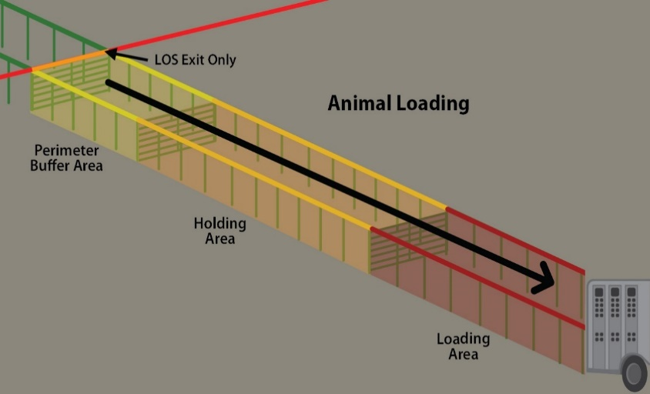
Graphic illustration of staged animal loading that is shared with animal unloading; replace with photo or diagram of your shared, staged loading area (optional)
OR
ANIMAL UNLOADING (SEPARATE, DEDICATED AREA) AT THE PERIMETER: The facility is located far enough away from the loading area to prevent cross-contamination of vehicles, personnel, equipment, and animal waste from each loading/unloading area. The handler does not cross to the inside of the LOS through the animal entry point; handlers follow the biosecure entry procedures at a people LOS Access Point.
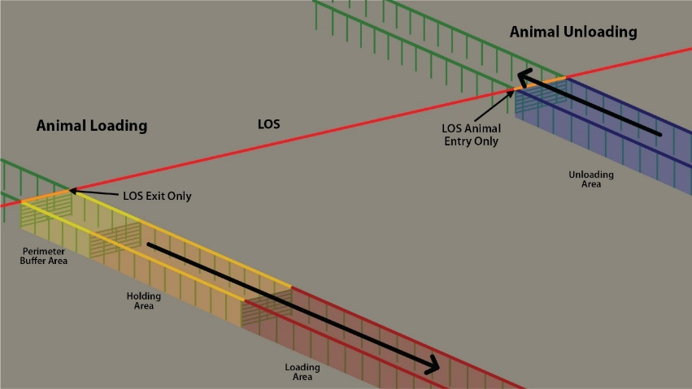
Graphic illustration of a separate and dedicated animal loading and unloading areas; replace with photo or diagram of your loading area (optional)

Animal Products

Semen, Embryos
Delete this section if not applicable
(pick one, modify/delete the other)
☐ This operation does not introduce semen or embryos from off-site locations.
OR
☐ The Biosecurity Manager will ensure that any semen or embryos collected after FMD has been diagnosed in the U.S. and introduced to this operation come only from sources with documented, enhanced biosecurity practices and have no current or previous evidence of FMD infection.
- Semen and embryos must be held and frozen at the source herd for 14 days after collection, and animals re-evaluated for signs of FMD after the 14 days before shipping.
- Semen and embryos are transported in containers whose exteriors can be cleaned and effectively disinfected as it crosses the LOS
- The source herd must document Active Observational Surveillance for at least 14 days prior to movement of product.

Feeding Dairy Products (pick one, delete the other)
Cattle on the operation:
☐ Are fed dairy products (e.g., whey) that have been treated to OIE recommendation for inactivation of FMD virus for animal consumption.
OR
☐ Are not fed dairy products.

Carcass Disposal
In an FMD outbreak, dead animals (normal mortality numbers) are disposed of by [List method of disposal, e.g., burial, incineration, composting] which prevents the attraction of wildlife, rodents, and other scavengers, and is in accordance with state and federal laws.
☐ Movement permits (if required) for carcasses going off-site will be requested from the regulatory officials managing the FMD outbreak
☐ Rendering trucks and other vehicles hauling dead animals to a common disposal site do not cross the LOS.
☐ Routes for carcass movement and disposal are labeled on the premises map at the end of this plan.
In the event of a large number of mortalities unrelated to FMD infection (toxicity, heat stress, etc.), dead animals will be disposed of by [List method of disposal, e.g., burial, incineration, composting] which also prevents the attraction of wildlife, rodents, and other scavengers, and is in accordance with state and federal laws.

Manure Management
Manure is stored [describe how – lagoon, slurry, composted, etc.]
In the event of a prolonged outbreak, we can store manure for [days, weeks, months]. After that time, the method for manure removal is [methods]. This will prevent exposure of susceptible animals and meet state, local and Responsible Regulatory Officials regulations.
(Pick one, modify, delete the other)
☐ Operation-specific dedicated manure handling equipment is used and equipment is not shared with other operations unless absolutely necessary
OR
☐ All manure handling vehicles and equipment from other sites must be cleaned to remove all manure and disinfected with either heat or a chemical disinfectant followed by drying. All manure handling personnel must have showered and changed into clean clothes and footwear prior to arriving at the operation. These expectations have been communicated to contract companies, and signed and dated when read. This communication is kept on file here: [location]. In the event that manure handling equipment from another location cannot be effectively C&D, a plan to temporarily modify the LOS near the manure storage facility during manure removal is in place. The affected areas are cleaned and disinfected before returning to the original LOS.

Rodent, Wildlife and Other Animal Control
The following control measures are in place to minimize interaction between cattle and other animals (deer, feral pigs, rodents, dogs, cats, etc.)
(pick one of the following, modify, delete the other)
☐ This operation uses [describe method(s)] to discourage rodent movement and has designated [individual’s name] as the rodent control monitor responsible for implementing the rodent control plan. Bait is checked [frequency] by [name or position title] and replaced as needed. This protocol is in accordance with state and local regulations for controlling rodents.
OR
☐ This site works with [professional rodent company] and has documentation describing the frequency and observations by the company representative. This protocol is in accordance with state and local regulations for controlling rodents.
(Mark those that apply, provide details where requested)
☐ Weeding and grass control is done [describe frequency].
☐ The sanitation of general office areas is completed [frequency].
☐ Trash and recycling is removed every [frequency]. In an outbreak, the garbage or recycling truck [would/would not] cross the LOS.
☐ Feed spills are cleaned up immediately by [describe who].
☐ We are [able/unable] to prevent wildlife access to livestock on this operation.
☐ Dogs, cats, and other pets are NOT allowed to roam between operations during an outbreak.
OR
☐ There are no dogs or cats on this operation.

Feed
Grain and feed commodities are delivered in trailers that are covered during transport.
In an outbreak, feed trucks delivering feedstuffs or finished feed would (Pick one, modify, delete the other)
☐ Cross the LOS through an LOS Access Point
OR
☐ Auger feed across the LOS into a farm vehicle/feed wagon located on-site.
Feed spills are cleaned up as soon as possible to minimize attraction of wildlife and rodents.

Labeled Premises Map
Guidance for Creating a Premises Map (satellite images are preferable) can be found at www.securebeef.org/beef-producers/biosecurity/.
Premises Address: [911 address]
Premises ID (PIN):
Label your premises map with the following items and include a legend. Adding building and area labels is recommended to visualize where animals are housed, people enter, feed is stored.
Public road
Line of Separation (LOS)
LOS Access Point
Vehicle cleaning and disinfection (C&D) station(s)
Designated parking area
Animal loading and/or unloading area(s)
Carcass disposal/pickup location
Carcass removal pathways
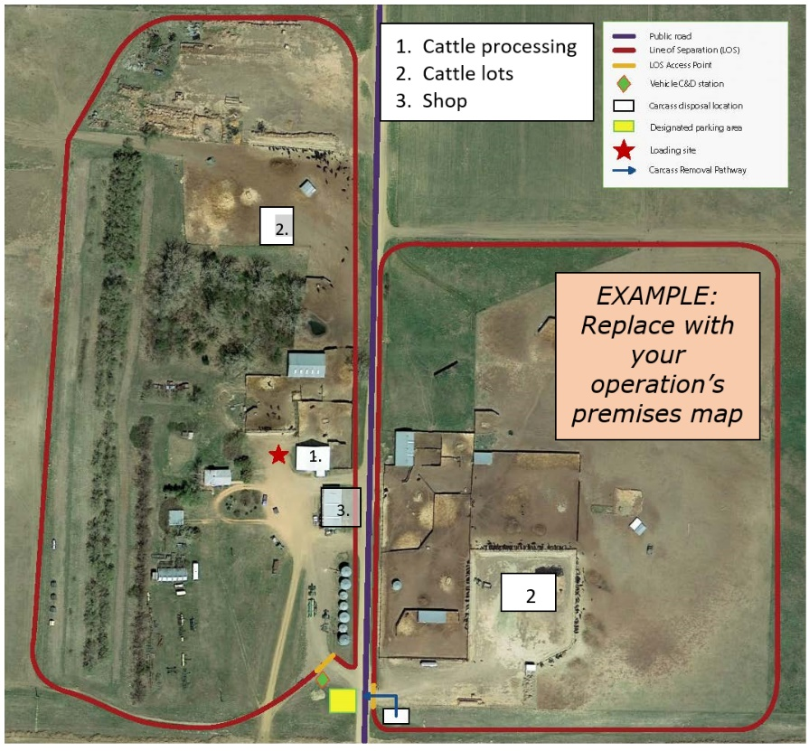
Deliveries (non-essential to the operation)

