

United States
Department of
Agriculture

Animal and
Plant Health
Inspection Service

Veterinary Services

Centers for
Epidemiology and
Animal Health

Viral Hemorrhagic Septicemia in the Great Lakes

July 2006
Emerging Disease Notice

Summary:

Viral hemorrhagic septicemia (VHS) has historically been considered to be the most serious viral disease of salmonids reared in freshwater environments in Europe. More recently, VHS has been associated with marine finfish species, and most recently has become an emerging disease of freshwater fish in the Great Lakes region of the United States and Canada.

VHS was first detected in the Great Lakes region in the Bay of Quinte, Lake Ontario, in 2005, and was subsequently detected in an archived 2003 sample from Lake St. Clair. VHS virus also was detected in Lake St. Clair in 2005 and in Lake Ontario, Lake Erie, Lake St. Clair and the St. Lawrence River in 2006 in a variety of fish species. Prior to 2003, isolations of VHS virus were limited in North America to saltwater finfish from the Atlantic and Pacific Oceans, including Chinook and Coho salmon, Pacific herring, Atlantic herring and cod. Since 2005, the list of species known to be affected by VHS has risen to more than 40, including a number of ecologically and recreationally important fish.

This Emerging Disease Notice describes the current status of viral hemorrhagic septicemia in the U.S., focusing on the 2005 and 2006 outbreaks in the Great Lakes area. This notice also quantifies trade and production statistics for relevant fisheries products and aquaculture resources and provides a qualitative assessment of potential risks and impacts of this disease in the event that it affects aquaculture fish species.

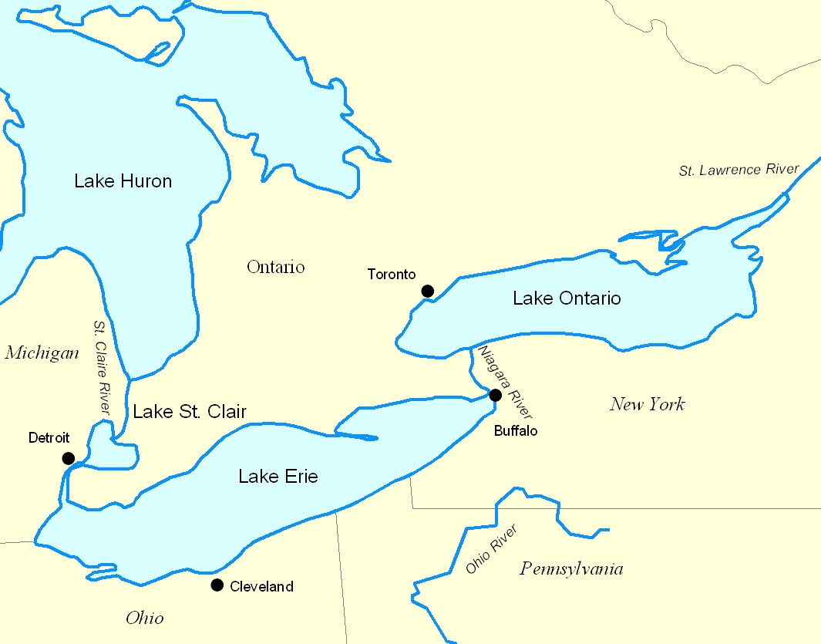

How extensive is viral hemorrhagic septicemia (VHS) in the United States?

Since Spring 2005, a number of die-offs have occurred in the Great Lakes area, including muskellunge, freshwater drum, round goby, yellow perch, smallmouth bass, bluegill, crappie, gizzard shad and other fish species (Table 1). Some of these die-offs reportedly involved large numbers of fish. VHS virus has been isolated and confirmed from these die-offs. VHS has also been detected in samples of walleye, white bass, and silver redhorses and shorthead redhorse suckers that were not part of a die-off and were not symptomatic. It is not known how VHS virus was transferred to the Great Lakes, or how long it has been in the ecosystem; however, one possible scenario is that the virus may have mutated from a marine form and become newly pathogenic to naïve freshwater fish species.

In support of this theory, genotyping of an isolate of VHS virus from muskellunge in Lake St. Clair, Michigan, has revealed an apparently new substrain of the North American VHS genotype. Preliminary studies of the Great Lakes VHS genotype show that it causes moderate mortality in salmonids (Lake Trout, Chinook salmon and Steelhead trout). Many recreationally important populations of these salmonids, which were originally introduced and have since become established, exist in the upper portion of the Great Lakes area where outbreaks of VHS have not yet been detected. In addition, cage culture of salmonids occurs on the Ontario side of the Great Lakes, though not on the U.S. sides.

Baitfish also represent an area of concern for the potential introduction and/or spread of VHS. Fish belonging to a large number of cyprinid and other species are collected from the Great Lakes and used as bait for sport fisheries around the U.S. Baitfish from Canada are routinely exported to the U.S. Additionally, some aquaculture producers collect baitfish broodstock from the Great Lakes to produce commercial baitfish in aquaculture facilities. The destinations and numbers of baitfish moved are not well documented, and regulation of this sector is inconsistent among States, or lacking entirely.

Live sale of fish by commercial fishers is also a concern. Fish from Lake Erie are sold live in Ontario, Canada for transport to pond aquaculture facilities in the Midwest U.S. The species, volume and destinations of these fish are not well documented.

Table 1. Outbreaks of Viral Hemorrhagic Septicemia in the Great Lakes 2005-2006
Date | Location | State or Province | Primary species  (Other species) | Estimated | Comments
2003-05 | Lake St. Clair | MI | Muskellunge | 4 of 27 | Samples submitted over several years
Summer 05 | Bay of Quinte/Lake Ontario | Ontario | Freshwater Drum  (Muskellunge  Round Goby) | Several hundred tons | Very large natural mortality
May 06 | Sandusky Bay/Lake Erie | OH | Freshwater Drum | Very large mortality | "Windrows" of fish on beach
May 06 | St. Lawrence River | NY | Round Goby  (Muskellunge) | Large die off | River origin
May 06 | Lake Erie | OH | Yellow Perch | Large die off | Fish dying in commercial traps
May 06 | Lake Ontario | Ontario | Freshwater Drum  Smallmouth Bass  Bluegill  Crappie | Mortality event | Acute mortality - no external signs
May 06 | Lake Erie | OH | Yellow Perch  Walleye  White bass  (Freshwater Drum  Smallmouth Bass) | Mortality in wild | Samples from area of traps and mortality
June 06 | Lake St. Clair | MI | Gizzard shad  Redhorse sucker  Blunt nose sucker  Northern pike  (Yellow perch) | Large mortality

What is VHS and where does it occur?

VHS is caused by an aquatic rhabdovirus. It has long been considered a serious disease of rainbow trout and a few other freshwater fish species raised for commercial aquaculture in Europe. Known as Egtved virus in these fish populations, VHS virus causes high mortality and can have severe economic consequences. For this reason, VHS is listed as a reportable disease by the World Organization for Animal Health (the OIE ─ formerly the Office International des Epizooties). Related VHS virus strains have also been isolated from a variety of marine fishes in the North Pacific, North Atlantic, and seas around northern Europe and Japan.

Four genotypes of VHS virus have been identified, and appear to be distributed geographically, rather than by host or year of epizootic occurrence. Genotypes I, II, and III are mainly found in Europe and Japan, while isolates of genotype IV have been recovered only from fish in North America, Japan and Korea. The pathogenicity of VHS virus varies by genotype and species affected. The VHSV isolates originating from wild marine fish show no or low pathogenicity in rainbow trout and Atlantic salmon, although several are pathogenic to turbot. The European/Asian freshwater isolates are highly pathogenic to rainbow trout.

VHS virus was first reported in the United States in 1988 in spawning salmon in the Pacific Northwest. The disease has been found in both wild and hatchery raised salmon in the Pacific Northwest. VHS is now enzootic among Pacific herring and Pacific cod populations off the coast of Alaska, Canada, and Washington State. In the Atlantic Ocean, the virus has been isolated from Atlantic herring and Greenland halibut. Although the North American strain of VHS virus is moderately pathogenic to herring, causing occasional self-limiting epizootics, it is relatively avirulent for several species of marine salmonids.

The number of wild fish species found to be susceptible to the North American genotype of the VHS virus is growing, with at least 40 different species (both freshwater and marine) testing positive for the virus. Susceptible fish species are found among the Salmoniformes (salmon, trout), Esociformes (pike), Clupeiformes (herring, anchovy), Gadiformes (cod), Pleuronectiformes (flounders, soles, other flatfishes), Osmeriformes (smelt), Perciformes (perch, drum), Scorpaeniformes (rockfishes, sculpins), Anguilliformes (eels), Cyprinodontiformes (mummichog) and Gasterosteiformes (sticklebacks).

The European/Asian freshwater genotype of the VHS virus is readily transmissible to fish of all ages, primarily via the urine. Survivors of infection can be lifelong carriers and shedders. Once VHS virus is established in farmed fish stock, and in associated watersheds, the disease becomes enzootic due to carrier fish, including cultured and wild populations. The virus has been isolated from feral fish in waters receiving hatchery effluent and can persist in water for several days. Control methods for VHS currently rely on fish health surveillance programs and measures such as eradication and fallowing. These procedures have been shown to be effective and have resulted in the elimination of VHS from several parts of Europe.

All VHS viruses can be recovered from homogenates of internal organs, sex products, or urine. Little virus can be recovered from feces. Experimentally, fish can be infected by cohabitation, immersion, intraperitoneal and intramuscular injection, brushing virus on the gills, and feeding virally spiked food.

Fish-eating birds, such as the gray heron, can be mechanical vectors of VHS virus, but passage through the gastrointestinal tract of birds appears to inactivate the virus. The virus does not appear to be transmitted by parasitic vectors or to be capable of replication in insects. In the hatchery environment, mechanical transfer of VHS virus on the surface of animate or inanimate objects presents a substantial hazard.

What is the size of the aquaculture industries of susceptible species in the U.S. and in affected states?

Sources: International Database on Aquatic Animal Diseases (through OIE Collaborating Centre for Information on Aquatic Animal Diseases at the CEFAS Weymouth Laboratory, UK). Viral Hemorrhagic Septicemia of Fishes, Fish Disease Leaflet 83, U.S. Department of the Interior, Fish and Wildlife Services, 1990. Viral haemorrhagic septicaemia virus in marine fish and its implications for fish farming – a review. H.F. Skall, N.J. Olesen, and S. Mellergaard; Journal of Fish Diseases, Volume 28 Page 509 - September 2005, doi:10.1111/j.1365-2761.2005.00654.x

Production from the four states that border the lower Great Lakes (New York, Pennsylvania, Michigan, Ohio) where VHS virus has been isolated comprised just over 1% of the total value of U.S. aquaculture food fish production in 1998, the most recent year that these data are available (Table 2). These states also contributed about 2% and 3% of the total value of baitfish and sport/game fish production in the U.S., respectively.

Baitfish is of concern for potential VHSV spread due to the distribution of these fish to broader geographical areas. According to the 1998 Census of Aquaculture Point of First Sale data, baitfish raised in New York, with a value of $38,150 were sold to live haulers, while the corresponding figure for cultured baitfish sales in Ohio was about $23,250. Additionally, baitfish sales for fee-fishing and recreational usage amounted to $56,300 and $429,000, respectively, in New York and Ohio.

Production of taxonomic groupings of food fish that are susceptible or likely to be susceptible to VHS are shown in Table 3. The states bordering the lower Great Lakes housed 110 trout farms during 1998, about 20% of the total number of trout production facilities in the U.S. These states, led by Pennsylvania and Michigan, contributed $7,800,000, accounting for 11% of the total value of U.S. trout production.

As indicated, VHS virus isolation has been documented in several species of sport and game fish in the wild. Four of these species that are cultured in the affected states for release are shown in Table 4. Although with a relatively small value of $339,000, cultured largemouth bass in the lower Great Lakes states accounted for about 8% of the value of national sales for this species.

Fish released from hatchery systems that are used for restoration and conservation purposes constitute another potential pathway for VHSV transmission. Species cultured for release to the wild in the lower Great Lakes area are trout, salmon, bass and walleye. Based on Census of Aquaculture data, there were 38 such trout hatcheries distributed throughout the four affected states in 1998.

Pennsylvania housed 14 of these, followed by New York with 10, and Michigan and Ohio with seven each. An estimated 16 million fingerling trout were distributed by these hatcheries in 1998. In addition to trout hatcheries, the affected states housed 13 walleye, 12 salmon (New York only) and 11 bass hatchery facilities.

The U.S. produced almost 25,000 tons of rainbow trout in aquaculture environments in 2004, accounting for 5 % of the world’s total.
Source: United Nations FAO, Fishstat

Table 2. Value of cultured food fish, bait fish, and sport/game fish production for the U.S. and selected states
 | Food fish |  | Baitfish |  | Sport/game fish
 | Number farms | Sales ($1,000s) | Number farms | Sales ($1,000s) | Number farms | Sales ($1,000s)
U.S. total | 2,168 | 691,714 | 275 | 37,482 | 204 | 7,390
New York | 38 | 1,025 | 14 | 149 | 12 | 124
Pennsylvania | 43 | 6,039 | 8 | (D) | 5 | 67
Michigan | 41 | 1,636 | 4 | (D) | 8 | 52
Ohio | 22 | 648 | 12 | 541 | 16 | 388
Source: 1998 Census of Agriculture
D = Information suppressed to avoid disclosure for individual farms

Table 3. VHS-susceptible food fish; value of production for the U.S. and selected states
 | Trout* |  | Hybrid striped bass |  | Perch |  | Walleye
 | Number farms | Sales  in $1,000s | Number farms | Sales  in  $1,000s | Number farms | Sales  in  $1,000s | Number farms | Sales  in  $1,000s
U.S. total | 561 | 72,473 | 88 | 28,173 | 75 | (D) | 38 | 1,213
NY | 30 | 920 | 1 | (D) | 4 | 10 | 1 | (D)
PA | 38 | 5,428 | 3 | (D) | 3 | (D) | 1 | (D)
MI | 34 | 1,148 | 1 | (D) | 5 | (D) | 3 | (D)
OH | 8 | 307 | 3 | (D) | 10 | 80 | 3 | 53
Source: 1998 Census of Agriculture
* The value of trout production includes food fish, stockers, and fingerlings.
D = Information suppressed to avoid disclosure for individual farms

Table 4. VHS-susceptible sport/game fish; value of production for the U.S. and selected states
 | Bluegill |  | Crappie |  | Largemouth bass |  | Sunfish
 | Number farms | Sales  in  $1,000s | Number farms | Sales  in  $1,000s | Number farms | Sales  in  $1,000s | Number farms | Sales  in  $1,000s
U.S. total | 129 | 1,790 | 39 | 310 | 136 | 4,450 | 28 | 542
NY | 2 | (D) | 4 | 3 | 11 | 120 | 0 | (D)
PA | 4 | (D) | 1 | (D) | 4 | 30 | 1 | (D)
MI | 7 | 30 | 1 | (D) | 2 | (D) | 1 | (D)
OH | 10 | 108 | 2 | (D) | 15 | 189 | 2 | (D)
Source: 1998 Census of Agriculture
D = Information suppressed to avoid disclosure for individual farms

What is the place of the U.S. in the international market for susceptible fish species? What are U.S. exports of relevant fish species and related products?

In addition to the potential effects of VHS on cultured fish species, there are several species of fish which are commercially caught in the lower Great Lakes and which are susceptible or likely to be susceptible to VHS. Total catch for these vulnerable species from lakes Erie, Ontario, and St. Clair amounted to about 1.3 million pounds during 1999 (Table 5). Lake Erie yielded the vast majority of the catch and, by weight, yellow perch comprised 57% the species caught in the three affected bodies of water.

Table 5. Commercial fisheries catch in the lower Great Lakes, by state and selected species, 1999.

 | Thousands of pounds
 | MI | NY | OH | PA | Total
Gizzard shad | 6 | 0 | 105 | 0 | 111
Rock bass | 0 | 1 | 0 | 0 | 1
White perch | 0 | 0 | 131 | 0 | 131
Sunfish | 0 | 2 | 0 | 0 | 2
Northern pike | 0 | 1 | 0 | 0 | 1
Suckers | 2 | 0 | 32 | 2 | 36
Burbot | 0 | 1 | 0 | 8 | 9
White bass | 0 | 0 | 221 | 0 | 221
Yellow perch | 0 | 40 | 697 | 3 | 740
Drum  (sheepshead) | 0 | 0 | 35 | 1 | 36
Total | 8 | 45 | 1,221 | 14 | 1,288
Source: Great Lakes Fisheries Commission

According to Great Lakes Fisheries Commission data, the fish species represented on Table 6 accounted for about 36% of all species caught in the lower Great Lakes in 1999. The number of different species that are known to be susceptible to the Great Lakes strain of VHS virus is increasing and detailed information on the status of other Great Lakes species of fish regarding their susceptibility to VHS is not known.

The United States wild caught fish numbers show that over 3,000 tons of fish were caught in 2004, the majority being gizzard shad, yellow perch, and freshwater drum (Table 6).

Products from both aquacultured and wild caught fish totaled over 1 million tons in both 2003 and 2004 (Table 7).

Quantities of live fish (except for eel) are not reported through WTA, but values serve as a good representation of the magnitude of the volume of fish being exported. The US exported $231,000 worth of live trout in 2005, and $137,000 from January to April 2006 (Table 8). The NESOI category (not elsewhere specified or included) does not give specific species, however some of the species affected by VHS would be included in this category.

The US exported $16.6 million worth of live fish, NESOI in 2005 and nearly 8 million from January to April 2006. The US also exported 501,442 KG (worth $5.6 million of live eel) in 2005, and 82,708 KG (worth $912,000) from January to April 2006. Canada, Chile, South Korea, Belgium and China were the primary recipients of these live fish exports from January through April, 2006. The U.S. exported nearly $200 million in whole fish or relevant fish products during 2005 and more than $90 million in fish or fish products during the first four months of 2006 (Table 8). Canada, Germany and Japan were the primary recipients of these exported products.
Source: World Trade Atlas

Table 6. Wild Caught, United States, 2003 and 2004
 | 2003 | 2004
 | Production (Tons) | Production (Tons) | % of World  Stocks
American gizzard shad | 2,321 | 1,870 | 100%
American yellow perch | 778 | 745 | 17.5%
Freshwater drum | 429 | 372 | 100%
Rainbow trout | 144 | 153 | 6.6%
Walleye | 12 | 12 | <0.1%
White bass | 76 | 146 | 100%
Total | 3,760 | 3,298
Source: United Nations FAO, Fishstat

Table 7. Aquaculture & Wild Caught Product, United States, 2003 and 2004
 | 2003 | 2004
 | Production  (Tons) | Production  (Tons) | % of World Production
Fish fillets, frozen | 219,461 | 211,193 | 9.8%
Fish flours fit for human consumption | 20,073 | 23,082 | 48.6%
Fish livers and roes, dried, smoked, salted or in brine | 545 | 5,543 | 8.8%
Fish livers and roes, frozen | 43,035 | 45,418 | 53.9%
Fish meat, whether or not minced, frozen | 388,695 | 375,936 | 29.1%
Fish oils, other than liver oils | 88,769 | 81,376 | 7.8%
Fresh or chilled fillets and other fish meat, whether or not minced | 136,491 | 128,651 | 25%
Livers and roes, fresh or chilled | 179 | 151 | 15.6%
Other fish, dried, whether or not salted but not smoked | 686 | 858 | <0.1%
Other fish, including fillets, smoked | 1,589 | 1,306 | 0.2%
Other fish, salted or in brine | 45 | 63 | <0.1%
Other flatfish, frozen | 15,619 | 15,547 | 13.2%
Other freshwater and saltwater fish, frozen | 216,019 | 122,320 | 6%
Prepared or preserved fish, excl. whole or in pieces | 2,194 | 2,420 | 0.1%
Total | 1,133,400 | 1,013,864
Source: United Nations FAO, Fishstat
Table 8: U.S. exports of relevant live fish and fish products, 2005 and January - April 2006
Live Fish or Product | 2005 |  | January - April 2006
 | Quantity (KG) | $Value (thousands) | Quantity  (KG) | $Value (thousands)
Live Fish, NESOI* | NA** | 16,619 | NA** | 7,979
Live Eels | 501,442 | 5,670 | 82,708 | 912
Live Trout | NA** | 231 | NA** | 137
Trout, Frozen (not Fillets) | 205,410 | 675 | 56,994 | 236
Trout, Fresh or Chilled (not Fillets) | 382,216 | 1,816 | 129,294 | 599
Fish or Fish Parts (not Fillets, Livers, Roes) | 66,421,483 | 168,078 | 21,803,898 | 52,128
Fish Livers and Roes, Frozen | 6,067,114 | 26,220 | 5,510,158 | 38,502
Total Fish Product Exports | 73,085,223 | 196,789 | 27,500,344 | 91,465
*NESOI – not elsewhere specified or included, specific species not given
**NA - not available
Source: World Trade Atlas

CEI’s plans for follow up:

No follow-up is currently planned regarding the outbreak of VHS in the US. If you need more information or to comment on this worksheet, you may contact Cindy Johnson at (970) 494-7332, or cynthia.l.johnson@aphis.usda.gov.

____________________________________
For more information, contact:

USDA:APHIS:VS:CEAH:CEI
NRRC Building B, M.S. 2E5
2150 Centre Avenue
Fort Collins, CO 80526-8117
970.494.7000
E-mail:Cynthia.L.Johnson@aphis.usda.gov
Or visit CEI on the Web at
http://www.aphis.usda.gov/vs/ceah/cei/

The U.S. Department of Agriculture (USDA) prohibits discrimination in all its programs and activities on the basis of race, color, national origin, age, disability, and where applicable, sex, marital status, familial status, parental status, religion, sexual orientation, genetic information, political beliefs, reprisal, or because all or part of an individual’s income is derived from any public assistance program. (Not all prohibited bases apply to all programs.) Persons with disabilities who require alternative means for communication of program information (Braille, large print, audiotape, etc.) should contact USDA’s TARGET Center at (202) 720–2600 (voice and TDD). To file a complaint of discrimination, write to USDA, Director, Office of Civil Rights, 1400 Independence Avenue, S.W., Washington, D.C. 20250–9410, or call (800) 795–3272 (voice) or (202) 720–6382 (TDD). USDA is an equal opportunity provider and employer.

